

WebMinds, Inc.

TM

Version v7.0

User Manual (For MacOS Users)

Version

Copyright © WebMinds, Inc., 2024

All Rights Reserved

This publication is protected by federal copyright law. No part of this publication may be copied or distributed, stored in a retrieval system, or translated into any human or computer language in any form or by any means, electronic, mechanical, magnetic, manual or otherwise, or disclosed to third parties without the express written permission of **WebMinds, Inc.**

**WebMinds, Inc.** makes no representation or warranties with respect to the contents hereof and specifically disclaim any implied warranties of merchantability or fitness for a particular purpose. Further, **WebMinds, Inc.** reserves the right to revise this publication and to make changes from time to time in the contents hereof without obligation of **WebMinds, Inc.** to notify any person or organization of such revision or changes.

**WebMinds, Inc.** has prepared this guide for use by **WebMinds, Inc.** personnel and authorized third parties as a guide to proper operation and/or maintenance of **WebMinds, Inc.** equipment and software. The drawings and specifications contained herein are the property of **WebMinds, Inc.**

Trademarked names may appear throughout this user manual. Rather than list the names and entities that own the trademarks or insert a trademark symbol with each mention of the trademarked name, the names are used only for editorial purposes and to the benefit of the trademark owner with no intention of infringing upon that trademark.

Address comments and corrections to:

**WebMinds, Inc.**

950 N Collier Blvd. Suite 400

Marco Island FL 34145

USA

Revision History

|  |  |  |  |
| --- | --- | --- | --- |
| Date | Release | Revision DESCRIPTION | MODIFIED BY |
| Mar 30, 2024 | 0.1 | Initial draft | David A. Flynn |
| Apr 07, 2024 | 1.0 | First base lined user manual | David A. Flynn |
|  |  |  |  |
|  |  |  |  |
|  |  |  |  |
|  |  |  |  |

About this User Manual

This user manual contains information about all the features & functionalities of the Duplicate Photo CleanerTM application & instructions on how to use them.

Purpose of this User Manual

The purpose of this user manual is to assist the end users of the TM application.

In Scope of this User Manual

The scope of this user manual includes the description and usage of the TM application.

Out of Scope of this User Manual

The scope of this user manual does not include –

* the detailed installation process of TM application
* the usage of the features and functionalities of your operating system

Intended Audience of this User Manual

The intended audiences of this user manual are –

* end users of the TM application

Organization of this User Manual

This user manual contains 11 chapters & 1 appendices as indicated below –

| chapter | Description |
| --- | --- |
| **Chapter 1** | Introduction |
| **Chapter 2** | Getting Started |
| **Chapter 3** | Registering your DPC Application Installation |
| **Chapter 4** | Activating your DPC Application Installation |
| **Chapter 5** | Entering a New Key |
| **Chapter 6** | Removing your DPC License Details |
| **Chapter 7** | Performing a Standard Scan |
| **Chapter 8** | Performing a Folder Comparison |
| **Chapter 9** | Performing a Photo Scan |
| **Chapter 10** | Performing a Lightroom Classic Scan |
| **Chapter 11** | Performing a Fragment Search |
| **Appendix A** | Frequently Asked Questions |

Typographical Conventions / Customaries used in this User Manual

The typographical conventions used in this user manual include the following –

* **Note:** The purpose of this typographical convention is to provide important information corresponding to an already stated fact. This is how we depict a note in this user manual –

**Note:**<Note Text><Note Text><Note Text><Note Text><Note Text><Note Text><Note Text><Note Text><Note Text><Note Text><Note Text><Note Text><Note Text><Note Text>

* **Tip:** The purpose of this typographical convention is to provide additional information supplementing an already stated fact. This is how we depict a tip in this user manual –

**Tip:**<Tip Text><Tip Text><Tip Text><Tip Text><Tip Text><Tip Text><Tip Text><Tip Text><Tip Text><Tip Text><Tip Text><Tip Text><Tip Text><Tip Text><Tip Text><Tip Text><Tip Text>

* **Warning:** The purpose of this typographical convention is to provide critical information corresponding to an already stated fact. This is how we depict a warning in this user manual –

**Warning:**<Warning Text><Warning Text><Warning Text><Warning Text><Warning Text><Warning Text><Warning Text><Warning Text><Warning Text><Warning Text><Warning Text>

* **Reference:** The purpose of this typographical convention is to refer you to another section in this user manual or another document or to an external reference. A reference is depicted in the following manner in this user manual –

**Reference:** To read detailed steps, navigate to **<Chapter Name>** chapter by clicking this link.

or

**Reference:** For more information, navigate to **<Chapter Name>** chapter by clicking this link.

Abbreviations / Acronyms used in this User Manual

The table below describes the abbreviations / acronyms used in this user manual –

|  |  |
| --- | --- |
| Abbreviation | Description |
| **GUI, UI** | Graphical User Interface, User Interface |
| **IPR** | Intellectual Property Rights |
| **DPC** | Duplicate Photo Cleaner |
| **TM** | Trade Mark |
| **TOC, TOT, TOF** | Table of Contents, Table of Tables, Table of Figures |
| **PC** | Personal Computer |
| **FAQs** | Frequently Asked Questions |
| **PTP** | Picture Transfer Protocol |
| **EXIF** | Exchangeable Image File Format |
| **DPI** | Dots Per Inch |
| **CSV** | Comma Separated Values |
| **UNC** | Universal Naming Convention |
| **LIFO** | Last In First Out |

Terms Used in this User Manual

The below table briefly describes the terms utilized in this user manual –

| chapter | Description |
| --- | --- |
| **End User** | An operator or user of the Duplicate Photo Cleaner TM application. |

**Table of Contents**

Revision History ii

About this User Manual iii

Purpose of this User Manual iii

In Scope of this User Manual iii

Out of Scope of this User Manual iii

Intended Audience of this User Manual iii

Organization of this User Manual iii

Typographical Conventions / Customaries used in this User Manual iv

Abbreviations / Acronyms used in this User Manual v

Terms Used in this User Manual v

Chapter - 1. Introduction 11

1.1 Downloading the DPC Application Installer 11

Chapter - 2. Getting Started 12

2.1 The Settings Panel Detailed Description 14

2.1.1 The General tab 14

2.1.2 The Scan Settings tab 17

2.1.3 The Logging tab 19

2.1.4 The Ignore List tab 20

2.1.5 The Sounds tab 21

2.1.6 The Support tab 22

2.2 Limitations of Utilizing an Unregistered DPC Application in Trial Mode 23

2.3 Performing General Functions during all Scan Types 23

2.3.1 Saving a Scan 23

2.3.2 Importing a Scan 25

2.3.3 Viewing Modes Available for the Results on the Scan Details page 27

2.3.4 Performing Multiple Types of Selections on the Scan Results page 31

2.3.5 Exporting your Scan Result Details as a File 33

2.3.6 Clearing the Displayed Scan Results from Scan Results page 36

2.3.7 Using the Mouseover Menu on the Image Preview 37

2.3.8 Scan Detail Page Actions Menu Descriptions 38

Chapter - 3. Registering your DPC Application Installation 55

3.1 Via the DPC Homepage 55

3.2 Via the Register Button of DPC Application 58

Chapter - 4. Activating your DPC Installation 61

Chapter - 5. Entering a New Key 64

Chapter - 6. Removing your DPC License Details 67

Chapter - 7. Performing a Standard Scan 70

Chapter - 8. Performing a Folder Comparison 74

Chapter - 9. Performing a Photo Scan 79

Chapter - 10. Performing a Lightroom Classic Scan 84

Chapter - 11. Performing a Fragment Search 89

Appendix - A. Frequently Asked Questions (FAQs) 95

Index 110

**Table of Figures**

Figure 1 – Downloading the Duplicate Photo CleanerTM application installer executable file 11

Figure 2 – Duplicate Photo CleanerTM default screen 12

Figure 3 – Duplicate Photo CleanerTM settings panel – the General tab 14

Figure 4 – Duplicate Photo CleanerTM settings panel – the Scan Settings tab 17

Figure 5 – Duplicate Photo CleanerTM settings panel – the Logging tab 19

Figure 6 – Duplicate Photo CleanerTM settings panel – the Ignore List tab 20

Figure 7 – Duplicate Photo CleanerTM settings panel – the Sounds tab 21

Figure 8 – Duplicate Photo CleanerTM settings panel – the Support tab 22

Figure 9: Scan Summary page 23

Figure 10: Scan Results page 24

Figure 11 – DPC application default screen – Importing a saved scan 25

Figure 12: Scan Summary page – saved scan data file successfully imported 26

Figure 13: Scan Results page 26

Figure 14: Viewing modes available for scan results on the scan details page 27

Figure 15: Viewing as Table 28

Figure 16: Viewing as MultiView 29

Figure 17: Viewing as Theatre 30

Figure 18: Multiple selection types available for scan results 31

Figure 19: Multiple export types available for scan results 33

Figure 24 – Scan Details Page Action buttons 38

Figure 25 – Search / Filter duplicates popup 39

Figure 26 – Search / Filter duplicates by file path and name 39

Figure 27 – Specifying the search string along with the wildcard * symbol 40

Figure 28 – Specifying the NOT checkbox 41

Figure 29 – Search / Filter duplicates by similarity value 41

Figure 30 – Search / Filter duplicates by similarity value between 20% and 99% 42

Figure 31 – Search / Filter duplicates popup 44

Figure 32 –Scan Details page 44

Figure 33 –Scan Details page – all duplicates selected – Search / Filter popup 45

Figure 34 –Scan Details page – all duplicates with Similarity percentage value equal to 100% 46

Figure 35 – Move to Folder popup 46

Figure 36 – Selecting all duplicate photos on the scan details page 47

Figure 37 – Link menu options – Symbolic link 48

Figure 38 – Viewing the log file after encountering an error 49

Figure 39 –Scan Details page 50

Figure 40 –Scan Details page – Selected all duplicate photos 51

Figure 41 –Scan Details page – Selected all duplicate photos 51

Figure 42 –Scan Details page – deleted all duplicate photos as per your selection 52

Figure 43 – The Settings Panel 54

Figure 44 – Registering your DPC application installation via the DPCTM homepage 55

Figure 45 – Specifying your registration details 56

Figure 46 – Secure Registration page 57

Figure 47 – DPC application default page 58

Figure 48 – DPC application license key specification – step 1 58

Figure 49 – DPC application license key specification – step 2 59

Figure 50 – DPC application license key specification – step 3 59

Figure 51 – DPC application license key activation successful 60

Figure 52 – DPC application default screen 61

Figure 53 – Activating DPC application – step 1 61

Figure 54 – Activating DPC application – step 2 62

Figure 55 – Activating DPC application – step 3 62

Figure 56 – DPC application license key activation successful 63

Figure 57 – DPC application default screen 64

Figure 58 – Removing DPC application license key details – About popup 65

Figure 59 – Activating DPC application – step 2 65

Figure 60 – Activating DPC application – step 3 66

Figure 61 – DPC application license key activation successful 66

Figure 62 – DPC application default screen 67

Figure 63 – Removing DPC application license key details – About popup 68

Figure 64 – Removing license key details confirmation popup 68

Figure 65 – Successful Removal of DPC application license key details 69

Figure 66 – Performing a Standard Scan – DPC default screen 70

Figure 67 – Selecting one or more folders 71

Figure 68 – Scan results summary page 72

Figure 69 – Scan results details page 72

Figure 70 – Scan Details Page Actions Menu 73

Figure 71 – Performing a Folder Comparison scan – DPC default screen 74

Figure 72 – Selecting the Folder Comparison option 75

Figure 73 – Selecting one or more source & target folders 76

Figure 74 – Scan results summary page 77

Figure 75 – Scan results details page 77

Figure 76 – Scan Details Page Actions Menu 78

Figure 77 – Performing a Photo Scan – DPC default screen 79

Figure 78 – Selecting the Photo Scan options 80

Figure 79 – Selecting the target Photo library 81

Figure 80 – Scan results summary page 82

Figure 81 – Scan results details page 82

Figure 82 – Scan Details Page Actions Menu 83

Figure 83 – Performing a Lightroom Classic Scan – DPC default screen 84

Figure 84 – Selecting the Light Room Classic scan options 85

Figure 85 – Selecting the target catalog of Lightroom Classic 86

Figure 86 – Scan results summary page 87

Figure 87 – Scan results summary page 87

Figure 88 – Scan Details Page Actions Menu 88

Figure 89 – Performing a Fragment Search – DPC default screen 89

Figure 90 – Selecting the source image and target folder(s) 90

Figure 91 – Selecting one or more source & target folders 91

Figure 92 – Scan results summary page 92

Figure 93 – Scan results details page 93

Figure 94 – Scan Details Page Actions Menu 94

Figure 95 – Installing DPC in macOS 95

Figure 96: Opening the Search / Filter window 104

Figure 97: Search / Filter window 104

Figure 98: Pausing a scan 107

# Introduction

With the advent of hand-held digital devices anyone with a decent smartphone with a good camera can capture his / her memories digitally alleviating the need to print each photograph. However, each use case scenario has its blessings and limitations. Even though, in the world of today storage space is cheap, it still requires some amount of maintenance and house-keeping activities. This is where Duplicate Photo CleanerTM (DPC) enables you to search for duplicate photos so that you can delete them in one go.

**Reference:** To view our Duplicate Photo CleanerTM promotional video, visit <https://youtu.be/mAUO57Y3QmA>

## Downloading the DPC Application Installer

You can download the Duplicate Photo Cleaner TM application from the **Download** link available in the menu on the Duplicate Photo Cleaner TM homepage as depicted in the figure below –

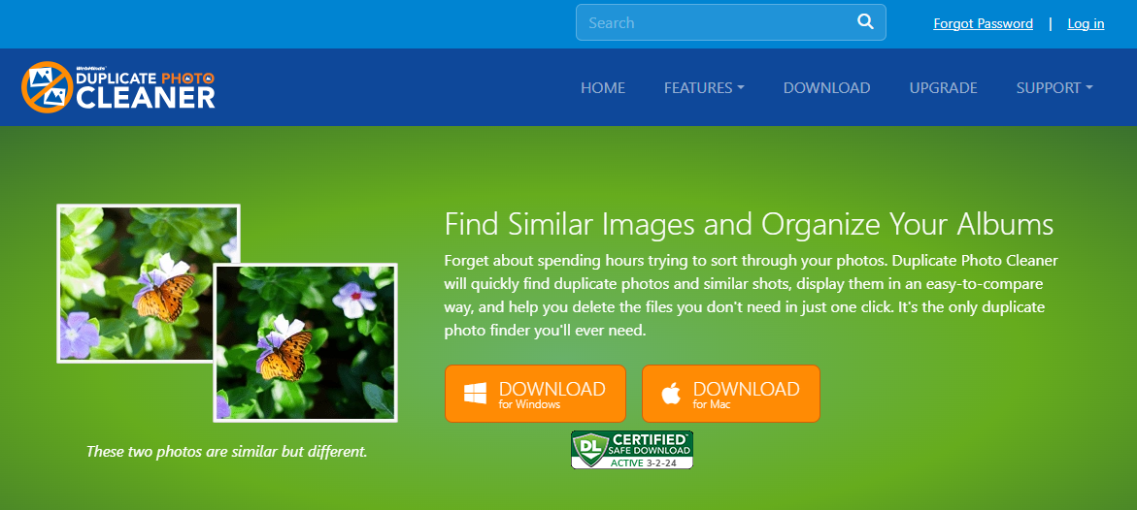

Figure 1 – Downloading the Duplicate Photo CleanerTM application installer executable file

You can follow the installation wizard by launching the downloaded Duplicate Photo Cleaner TM installer executable .dmg file to install the Duplicate Photo Cleaner TM application on your system.

**Tip:** While installing Duplicate Photo CleanerTM, you may be warned by macOS about a potential security risk since the executable file being installed has been downloaded from the internet. Please allow installing this application in the Security & Privacy section of your Mac System Settings.

The next chapter gets you started with the Duplicate Photo Cleaner TM application that you just installed.

# Getting Started

Double click on the desktop icon of Duplicate Photo CleanerTM application. Your DPC application will be launched as depicted in the figure below –

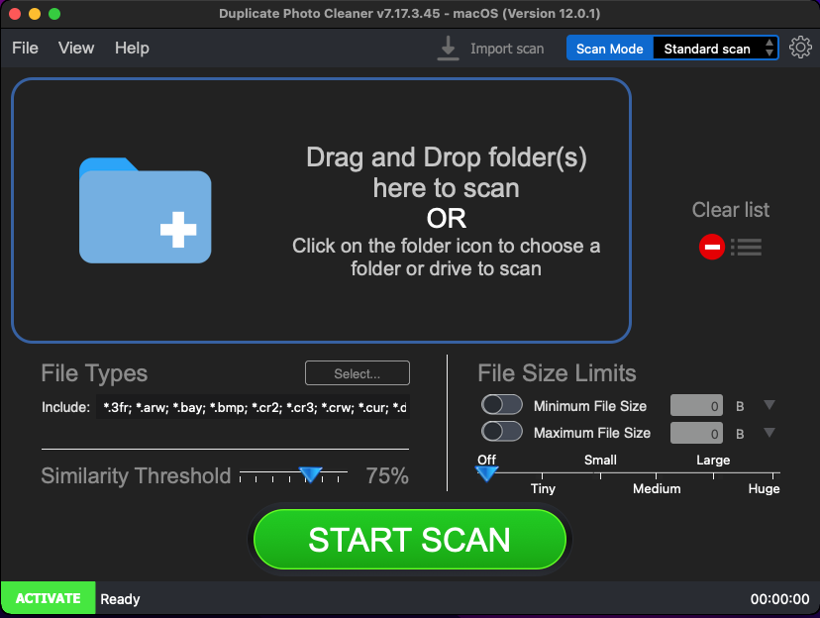

Figure 2 – Duplicate Photo CleanerTM default screen

Below is a description of the screen elements of the default screen of the TM application.

| **NO.** | | **DESCRIPTION** |
| --- | --- | --- |
| **1** | | This is the main toolbar of the DPC application. The main operations that you can perform using the options on the toolbar are as follows –   * **File –** This option enables you to –   + **Start a Scan** in the standard view as depicted in the figure above.   + **Exit –** This option enables you to close from the DPC application. * **View –** This option enables you to change the view of photos as they are displayed on your screen in all the modes on the scan details page. The available sub-options are described as follows –   + **as Table** – Using this option, you can view the scan details as a list of files as a table. The left table lists the original photos while the right table lists the duplicates.   + **as Tree** – Using this option, you can view the scan details as a tree; i.e., each of the duplicates are nested under their original photos.   + **as Multiview** – Using this option, you can view the scan details as thumbnailed list wherein each of the duplicates are listed to the right of their originals. Each thumbnail is also marked if it is Original or if it is a 100% duplicate of the original.   + **as Theatre** – Using this option, you can view the scan details in such a way the 80% of the screen displays the photo which is centered on the screen. Also, both the original photo thumbnails are listed along with their duplicates in the remaining 20% of the screen at the bottom as a slide list running from left to right. * **Help –** This option enables you to perform the following actions –   + **User Guide –** Clicking this option enables you to view this user guide.   + **Update –** Clicking this option enables you to check if any updates of the DPC application are available.   + **About –** Clicking this option enables you to view your license information in case you have registered DPC application installation. This option also enables to and purchase a license key depending on the package of your choice. Also, this sub-option enables you to register you application installation and activate it after the system validates your license key successfully.   **Reference:** To register your DPC application installation, refer to **Registering your DPC Application Installation** chapter by clicking this link.  **Reference:** To activate your DPC application installation, refer to **Activating your DPC Installation** chapter by clicking this link.  **Reference:** To remove your DPC application license details, refer to **Removing your DPC License Details** chapter by clicking this link.  **Reference:** To enter a new key, refer to **Entering a New Key** chapter by clicking this link. |
| **2** | | Clicking this scan type drop-down list enables you to specify the scan type you intend to perform. Chapters 7 to Chapter 11 describe each scan type in detail. |
| **3** | | This section indicates the current state of your DPC installation. In this case where it says **Activate**, indicates that your current DPC installation is not registered and activated.  **Reference:** An unregistered & inactivated DPC installation poses the 10-item clean limitation. To read more about this limitation, refer to the next sub-section.  Clicking the **ACTIVATE** button opens the Registration / Activation popup.  **Reference:** To register your DPC application installation, refer to **Registering your DPC Application Installation** chapter by clicking this link.  **Reference:** To activate your DPC application installation, refer to **Activating your DPC Installation** chapter by clicking this link. |
| **4** | Clicking this button opens the Settings panel.  **Tip:** For a detailed description of the Settings panel, refer to **The Settings Panel Detailed Description** section. | |

## The Settings Panel Detailed Description

This sub-section describes all tabs and all the provided parameters on each of these tabs on the Settings panel.

The General tab

The parameters available on the General are applicable on most of the common settings of the DPC application. Below are detailed descriptions of the General tab and its parameters as depicted in the figure below –

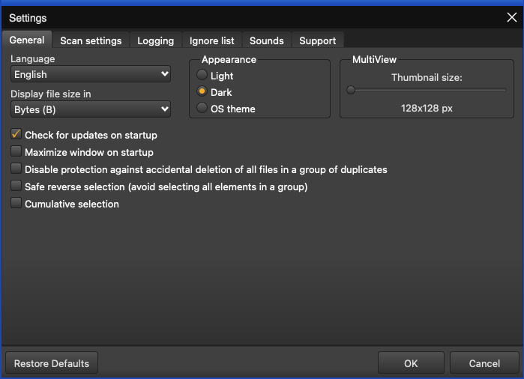

Figure 3 – Duplicate Photo CleanerTM settings panel – the General tab

* **General –** This tab includes all general settings that are application on DPC application.
  + **Language –** This drop-down list enables you to change the language of you DPC application installation.
  + **Display file size in –** This drop-down list enables you to specify the unit of measurement of data that is to be used to display the file size. e.g., In today’s world, most images are measured in mega-bytes or MBs.
  + **Appearance –** These mutually inclusive radio buttons enable you to specify which appearance theme is to be applied – i.e., Light, meaning the macOS light theme, Dark, meaning a macOS dark theme, or OS theme, meaning whatever the macOS theme is being used, that will be applied to DPC.
  + **MultiView –** This slider enables you to specify the size of the thumbnail that is to be utilized while DPC creates a temporary thumbnail of the actual image in all scan types
  + **Check for updates on startup –** This checkbox enables you to specify if DPC must check for updates when it is starting up
  + **Maximize window on startup –** This checkbox enables you to specify if DPC must maximize its window when it is starting up
  + **Disable protection against accidental deletion of all files in a group of duplicates –** Each group of duplicate photos identified in a scan contains the one photo with the best similarity percentages. In case the similarity percentages are identical then the shortest filename common in the group of the duplicate photos and / or the first file encountered satisfying the afore-mentioned conditions is considered as the original while the rest of the similar or identical photos are considered as duplicates. Now if we have selected these images & if we are trying to delete these photos, then DPC prevents us from deleting all of them by preserving the best candidate being considered as the original. This is how DPC keeps your photos safe & ensures that you never lose them forever due to a selection mistake. In other words, this is how DPC implements protection against accidental deletion of all files in a group of duplicates by default. In case you are sure of what you are doing, then you can select this checkbox to disabled this protection against accidental deletion of all files in a group of duplicates.
  + **Safe reverse selection (avoid selecting all elements in a group) –** Consider a scenario wherein just after performing a scan when you reach the scan details page and none of files / photos / images are selected and you click the Reverse selection option from the Select menu, then the following events will occur conditionally as described below –
    - **When Safe reverse selection is disabled –** In this case all images will be selected. Therefore, you risk losing your images in case the protection against accidental deletion of all files in a group of duplicates is also disabled.
    - **When Safe reverse selection is enabled –** In this case one image; i.e., the photo with the best similarity percentages or the one with the shortest filename in each group of duplicate photos is deselected to keep it safe from being deleted accidentally.
  + **Cumulative selection –** On the scan details page, after DPC has identified duplicate photos along with their original photos, and suppose you make a few manual selections of files or even by using any of the options like Select all but newest or Select all but oldest, etc. available on the Select menu, in case this setting is disabled on the Settings panel, then each subsequent selection will deselect all previous selections made and then all matching photos will be selected depending upon the option specified from the Select menu. Conversely, if this setting is enabled then in the case described in this point, previous selections are retained and newer selections are also performed by DPC depending upon the option specified from the Select menu.
* **Restore Defaults –** Clicking this button reverts all settings to the default mode of DPC.
* **OK –** Clicking this button saves the changes made and closes this panel
* **Cancel –** Clicking this button ignores the changes made and closes this panel

The Scan Settings tab

The parameters available on the Scan Settings tab enable you to fine tune the scan algorithm to produce better scan results during image comparisons. Below are detailed descriptions of the Scan Settings tab and its parameters as depicted in the figure below –

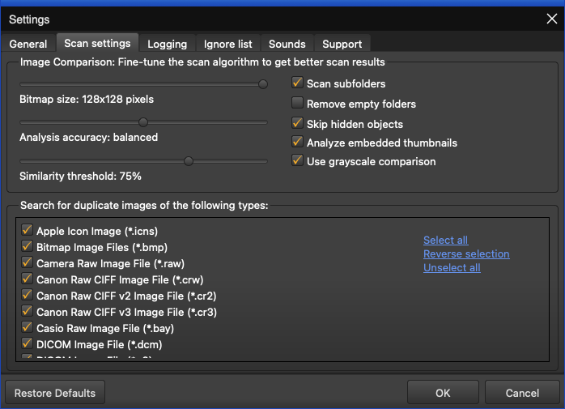

Figure 4 – Duplicate Photo CleanerTM settings panel – the Scan Settings tab

* **Bitmap size:** This slider enables you to set the bitmap size. Consider a scenario in which your images are lesser in resolution that 128 x 128 px. In such a scenario it would make more sense to reduce the size of the bitmap which is lesser than 128 x 128 px.
* **Analysis accuracy:** This slider enables you to set the threshold of the accuracy of analysis
* **Similarity threshold:** This slider enables you to set the threshold of the similarity being checked
* **Scan subfolders:** This checkbox enables you to set if sub-folders and their contents are to be check as well or not.
* **Remove empty folders:** Consider a scenario in which DPC has identified duplicate photos and listed them along with their original counterparts. In case a folder containing duplicates is emptied after DPC has removed the duplicate photos, selecting this option in the Settings panel instructs DPC to remove the parent empty folder as well.
* **Skip hidden objects:** This checkbox enables you to specify DPC to skip hidden items in a folder
* **Analyze embedded thumbnails:** EXIF thumbnails are thumbnails of images that are stored in the Exchangeable Image File Format (EXIF). i.e., each photo is associated with a Tagged Image File Format (TIFF) based 2-page file containing the meta data of the photo like the camera information on the first page and the second page containing the thumbnail. Therefore, while DPC analyzes a group of photos, if this option is enabled, then DPC takes lesser time to analyze each photo. This happens because DPC takes into consideration the EXIF data associated with the full resolution photo & utilizes the thumbnail in its scans instead of the full resolution photo thereby speeding up the scanning process.
* **Use grayscale comparison:** This checkbox enables you to specify whether DPC uses grayscale comparison method to scan for duplicate images.
* **Search for duplicate images of following types:** This easel enables you to which types of images are to be scanned for judging by their filename extensions.
  + **Select all:** This link enables you to select all types of image types in this easel.
  + **Reverse selection:** This link enables you to deselect the currently selected image types & select the unselected image types.
  + **Unselect all:** This link enables you to unselect all types of image types in this easel.
* **Restore Defaults –** Clicking this button reverts all settings to the default mode of DPC.
* **OK –** Clicking this button saves the changes made and closes this panel
* **Cancel –** Clicking this button ignores the changes made and closes this panel

The Logging tab

The parameters on the Logging tab enable you to specify which events are to be logged and how may days of logs must be to be retained. Below are detailed descriptions of the Logging tab and its parameters as depicted in the figure below –

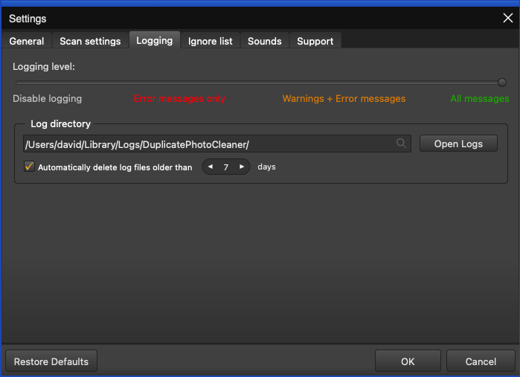

Figure 5 – Duplicate Photo CleanerTM settings panel – the Logging tab

* **Logging Level –** This slider enables you to set which types of application messages are to be logged (Disable logging / Error messages only / Warning + Error messages / All messages).
* **Log directory –** This field enables you to specify the path to the folder where all application message logs are to be stored
* **Open Logs –** Clicking this button enables you to view the contents of the logging folder where you can find all the application message logs.
* **Automatically delete log files older than X days:** This input control enables you to specify the number of days (X) for which the log files are to be retained. Files older than this value are discarded automatically for storage space optimization.
* **Restore Defaults –** Clicking this button reverts all settings to the default mode of DPC.
* **OK –** Clicking this button saves the changes made and closes this panel
* **Cancel –** Clicking this button ignores the changes made and closes this panel

The Ignore List tab

The parameters on the Ignore List tab enable you to specify which of the files within a folder to be scanned that DPC must ignore while performing the scan operation. As depicted in the figure below this exclusion list overrides any other options set within the DPC application. i.e., DPC application will not allow you to perform a scan, rename any contained file, and move or delete files in the specified folders.

**Warning:** You need to be extremely vigilant before performing a system wide scan. i.e., you must exclude all system folders as depicted in the figure below, before performing a system wide scan. It is not recommended to perform a system wide scan as DPC runs the risk of deleting images or photos being used in the stable functioning of your system.

Below are detailed descriptions of the Ignore List tab and its parameters as depicted in the figure below –

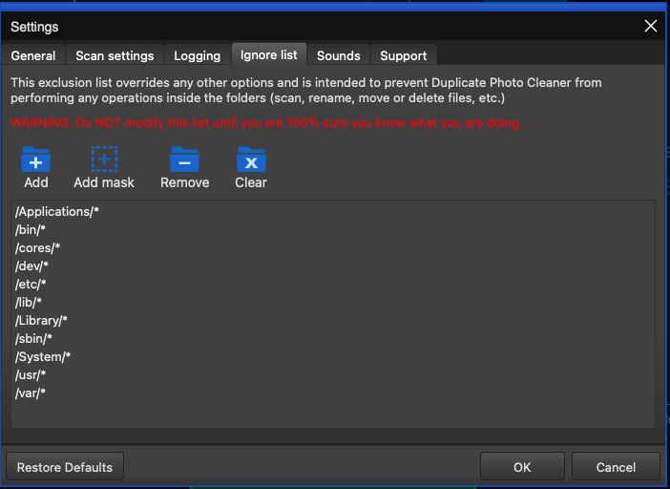

Figure 6 – Duplicate Photo CleanerTM settings panel – the Ignore List tab

* **Add –** Clicking this button enables you to add a folder to this ignore list
* **Add Mask –** Clicking this button enables you to add a string as a mask or wildcard entry to the ignore list. While performing a scan, DPC will check for any folder name containing this string and automatically ignore such a folder.
* **Remove –** After selecting a folder from the easel below, clicking this button enables you to remove that folder from this ignore list
* **Clear –** Clicking this button enables you to remove all specified folder in this ignore list
* **Restore Defaults –** Clicking this button reverts all settings to the default mode of DPC.
* **OK –** Clicking this button saves the changes made and closes this panel
* **Cancel –** Clicking this button ignores the changes made and closes this panel

The Sounds tab

The parameters on the Sounds tab enable you to specify the mp3 audio files to be played for each of the three events as described in the bulleted list below the figure. Below are detailed descriptions of the Sounds tab and its parameters as depicted in the figure below –

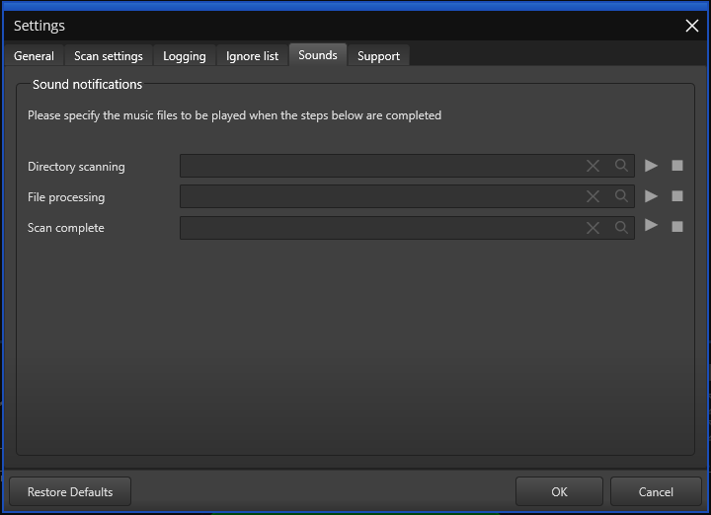

Figure 7 – Duplicate Photo CleanerTM settings panel – the Sounds tab

* **Directory scanning –** Clicking the Magnifying glass button enables you to navigate to an mp3 file which you can set for DPC to play when directory scanning is complete. Clicking the triangle Play button enables you to preview the mp3 audio file while the square Stop button stops the file you are previewing to stop playing.
* **File processing –** Clicking the Magnifying glass button enables you to navigate to an mp3 file which you can set for DPC to play when file processing is complete. Clicking the triangle Play button enables you to preview the mp3 audio file while the square Stop button stops the file you are previewing to stop playing.
* **Scan complete –** Clicking the Magnifying glass button enables you to navigate to an mp3 file which you can set for DPC to play when the specified scanning is complete. Clicking the triangle Play button enables you to preview the mp3 audio file while the square Stop button stops the file you are previewing to stop playing.
* **Restore Defaults –** Clicking this button reverts all settings to the default mode of DPC.
* **OK –** Clicking this button saves the changes made and closes this panel
* **Cancel –** Clicking this button ignores the changes made and closes this panel

The Support tab

The parameters on the Support tab enable you to prepare application specific detailed data in case your DPC application installation runs into an erroneous event. The Zip archive created by this tab is saved your system’s Documents folder which you can share with our support team. Below are detailed descriptions of the Support tab and its parameters as depicted in the figure below –

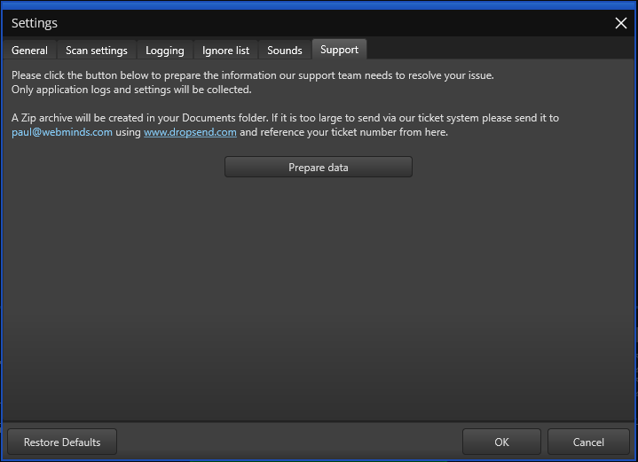

Figure 8 – Duplicate Photo CleanerTM settings panel – the Support tab

* **Prepare data –** Clicking this button collects all application specific data and saves it as a Zip archive in your system’s Documents folder which you can share with our support team.
* **Restore Defaults –** Clicking this button reverts all settings to the default mode of DPC.
* **OK –** Clicking this button saves the changes made and closes this panel
* **Cancel –** Clicking this button ignores the changes made and closes this panel

## Limitations of Utilizing an Unregistered DPC Application in Trial Mode

The trial version of Duplicate Photo CleanerTM offers unlimited scanning for duplicates and similar images in all scan types. You can then delete up to 10 duplicate groups with the trial version.

Therefore, it makes more sense to purchase a license package as per your usage requirements and specific use case scenario.

## Performing General Functions during all Scan Types

The main toolbar provides additional general functions that you can perform on the results list which are common to all scan types. The following sub-sections describe steps that enable to utilize these additional general functions.

### Saving a Scan

The steps described below enable you to save scan results as a file for later use –

1. Run a scan and wait for Duplicate Photo CleanerTM to view the scan summary page as depicted in the figure below –

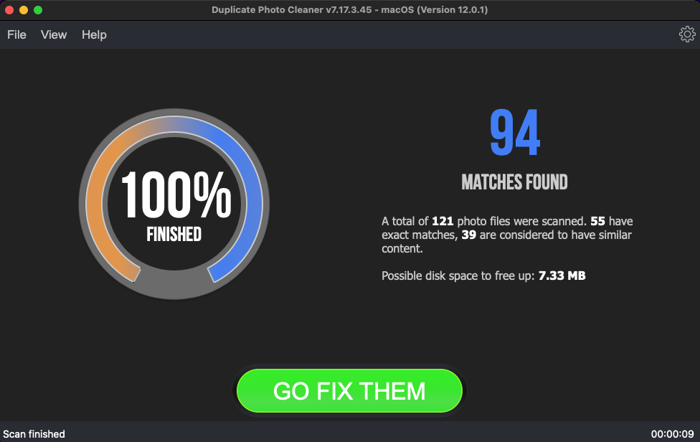

Figure 9: Scan Summary page

1. Click on the GO FIX THEM button. The results screen is displayed as depicted in the figure below –

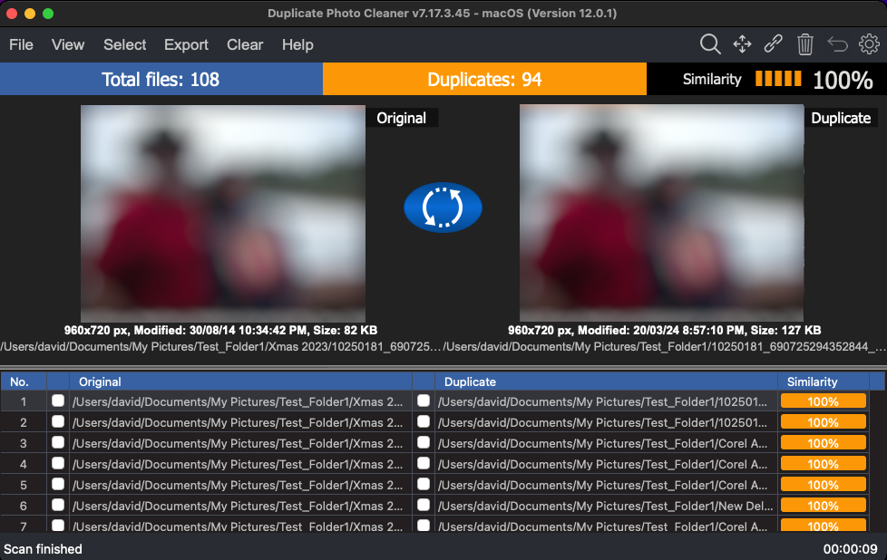

Figure 10: Scan Results page

1. From the main toolbar click on Export > Save Scan option. The Save dialog box is displayed which you can utilize to navigate to a folder location of your choice. Then you can specify a name for the scan data file and click Save. This is how you can save your scan details to your computer.

### Importing a Scan

The steps described below enable you to import a saved scan –

1. After you launch the DPC application, the default screen is displayed as depicted in the figure below –

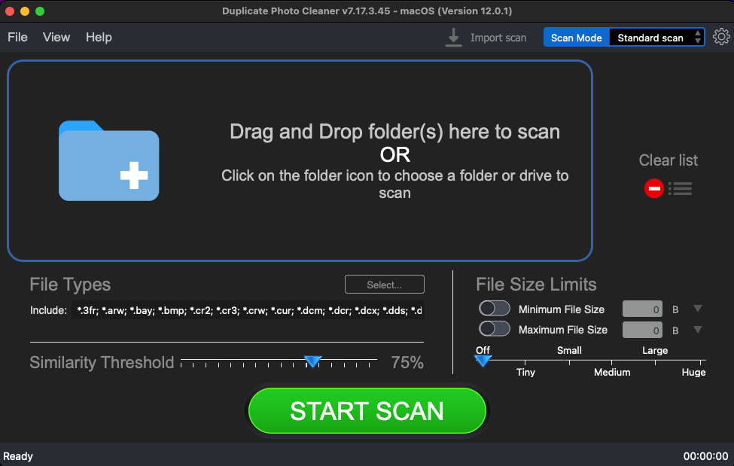

Figure 11 – DPC application default screen – Importing a saved scan

1. Click **Import Scan** as depicted in the figure above. The Import dialog box is displayed which you can utilize to navigate to the folder where you saved your scan results.
2. Select the scan data file and click Import. The scan results are successfully imported and the scan summary page is displayed as depicted in the figure below –

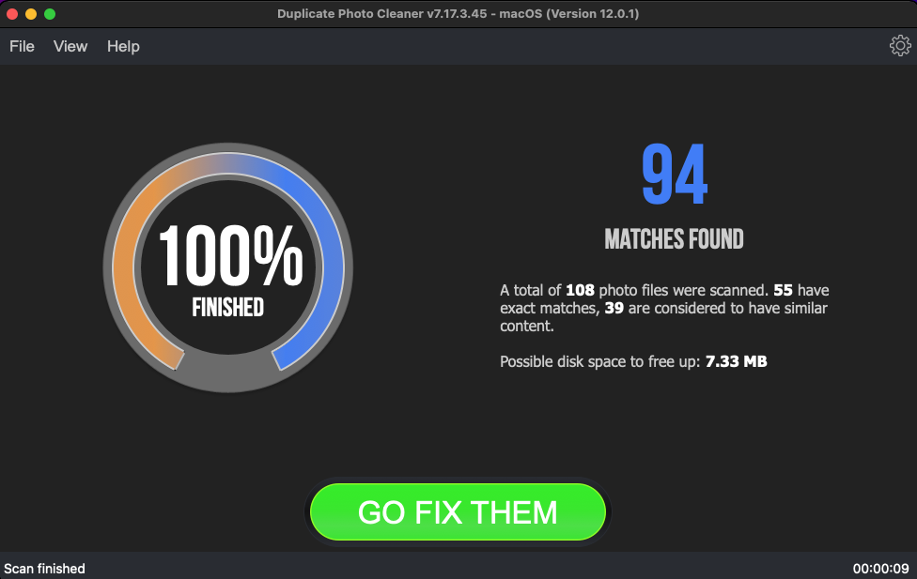

Figure 12: Scan Summary page – saved scan data file successfully imported

1. Click on the GO FIX THEM button. The results screen is displayed as depicted in the figure below –

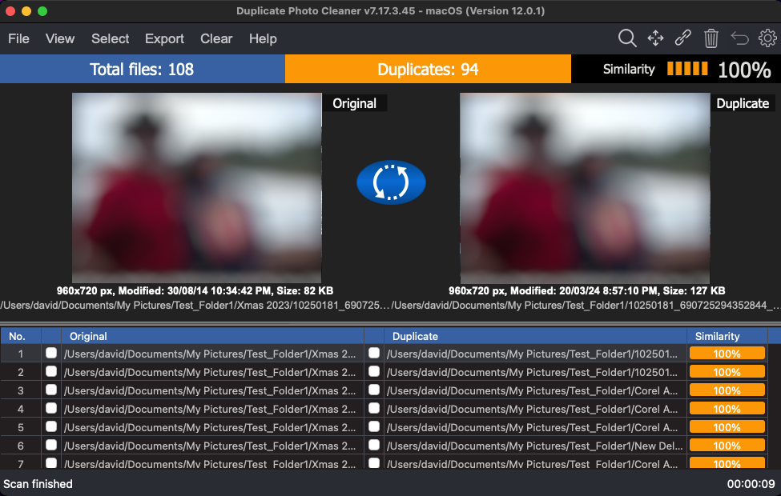

Figure 13: Scan Results page

Now you can perform all general functions described in the following sections.

### Viewing Modes Available for the Results on the Scan Details page

This sub-section describes all viewing modes available for the scan results that are displayed on the scan details page as depicted in the figure below –

* **View as Table –** This is the tabulated format in which the left column lists the original photos while the right column lists the duplicates as depicted in the figure below. Clicking this option enables you to select all duplicate images found in tabulated format as depicted in the figure below.

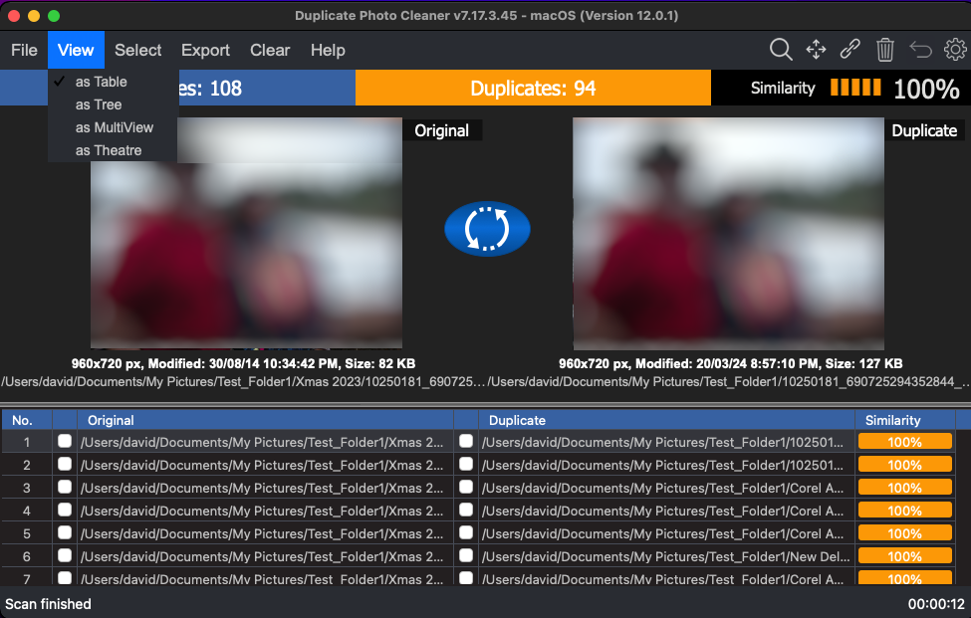

Figure 14: Viewing modes available for scan results on the scan details page

* **View as Tree –** This is the tree formatted scan details result output in which the original photos are listed as parent nodes while the duplicates of each of the original photos are listed nested as children to the parent node as depicted in the figure below. Clicking this option enables you to view all the original photos as well as the duplicates photos in Tree format as depicted in the figure below.

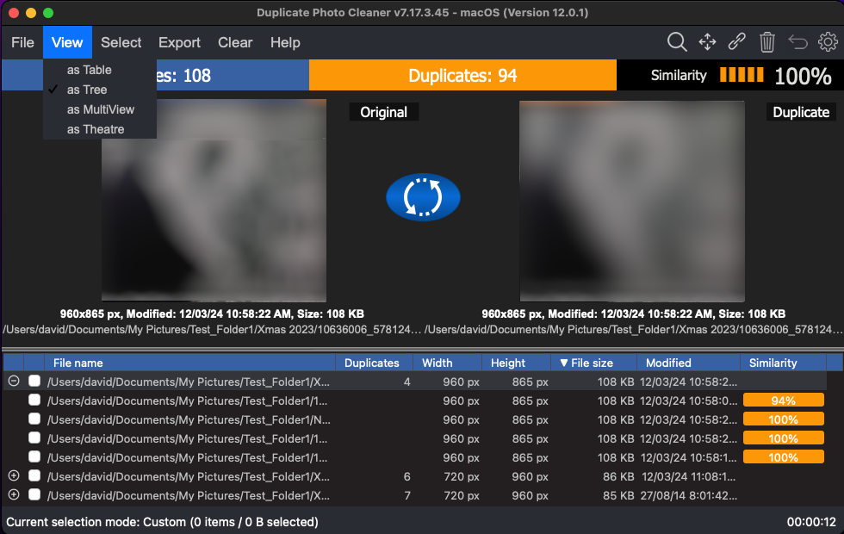

Figure 15: Viewing as Table

* **View as MultiView –** This is the multi-view format in which the original photos are listed first from left to right followed by their duplicates. Each file is label as whether it is an original or if it is a duplicate, then the match percentage is displayed as the label as depicted in the figure below. Clicking this option enables you to view the original photos as well as the duplicate photos in multi-view format as depicted in the figure below.

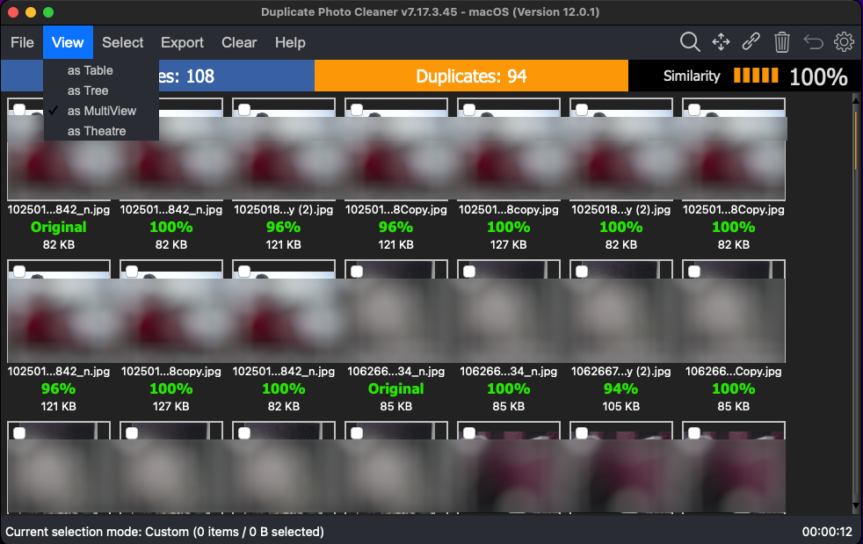

Figure 16: Viewing as MultiView

* **View as Theatre –** This is the theatre or slide-show format in which the original photos are listed first from left to right followed by their duplicates as depicted in the figure below. Clicking this option enables you to view the original photos as well as all duplicate images found in theatre format as depicted in the figure below.

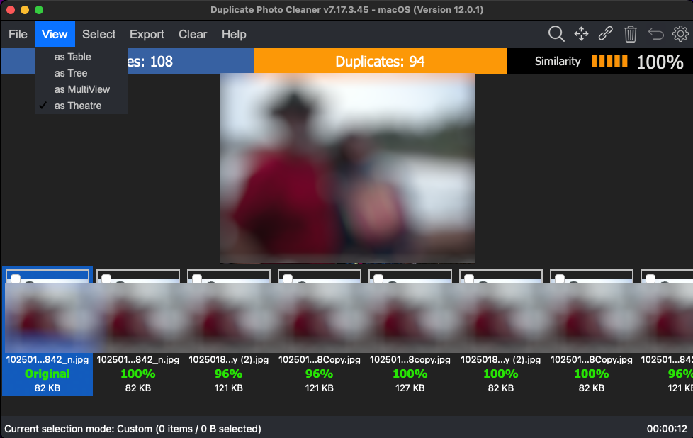

Figure 17: Viewing as Theatre

### Performing Multiple Types of Selections on the Scan Results page

This sub-section describes all the selection types that you can perform on the scan results that are displayed on the scan details page as depicted in the figure below –

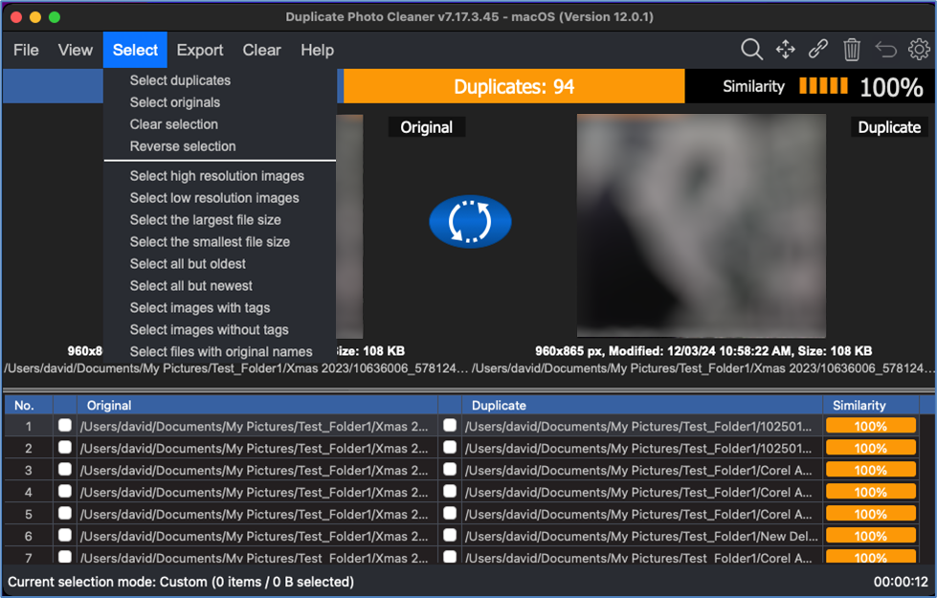

Figure 18: Multiple selection types available for scan results

* **Select duplicates –** Clicking this option enables you to select all duplicate images found
* **Select originals –** Clicking this option enables you to select all original images
* **Clear selection –** Clicking this option enables you to clear selection on this page
* **Reverse selection –** Clicking this option enables you to reverse selections i.e., all selected images are unselected and all unselected images are selected
* **Select high resolution images –** Clicking this option enables you to select high resolution images; i.e., images or photos with a high width x height value are selected when this option is clicked.
* **Select low resolution images –** Clicking this option enables you to select low resolution images; i.e., images or photos with a low width x height value are selected when this option is clicked.
* **Select the largest file size –** Clicking this option enables you to select the image with the largest file size
* **Select the smallest file size –** Clicking this option enables you to select the image with the smallest file size
* **Select all but oldest –** Clicking this option enables you to select all images except the oldest image found
* **Select all but newest –** Clicking this option enables you to select all images except the newest image
* **Select images with tags –** Tags are attributes that can be added to a few file types like image files, music files, video files, and some Microsoft Office files, though, not all file types support tags, so it is an inconsistent method to group all types of files but proves useful when it is available with the afore mentioned file types especially photos. You can manually right-click on a photo file and navigate to Properties > Details > Tags. Then you can add tag to the file being operated upon. Clicking this option enables you to select images with tag information populated against the tags detail in the file properties of the photo or image file.
* **Select images without tags –** As described above, and in short, tags are attributes you can add to each of the photo file as described in the previous point. Clicking this option enables you to select images without tag information populated against the tags detail in the file properties of the photo or image file.
* **Select files with original names –** In a scan result on the scan details page where the original photos are listed along with their duplicate counterparts, we see that the original file is typically has the shortest file name among similar file names in a group of original and duplicate photos. For example, if we have a group of files “A.jpg”, “A (1).jpg” and “A – Copy.jpg” then the original name is “A.jpg”. Clicking this option enables you to select files with original names

### Exporting your Scan Result Details as a File

This sub-section describes all the types of scan result details export that you can perform on the scan results that are displayed on the scan summary page –

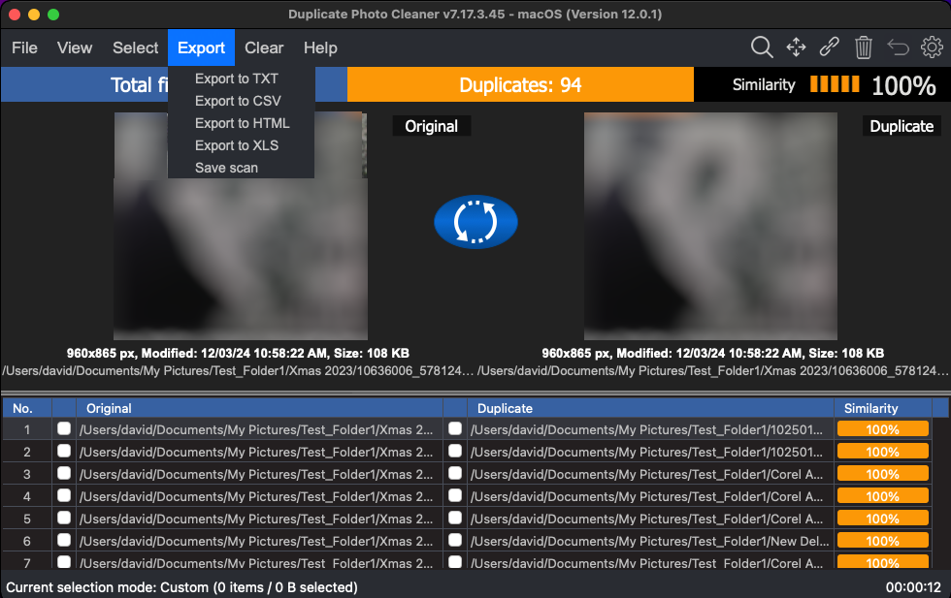

Figure 19: Multiple export types available for scan results

* **Export to TXT –** Clicking this option enables you to export selected file details as a text file. Once you have exported the selected file details as a Text file, after opening this file in notepad, the output includes key details of the scan along with a table depicted both original files listed with their duplicates as depicted in the figure below –

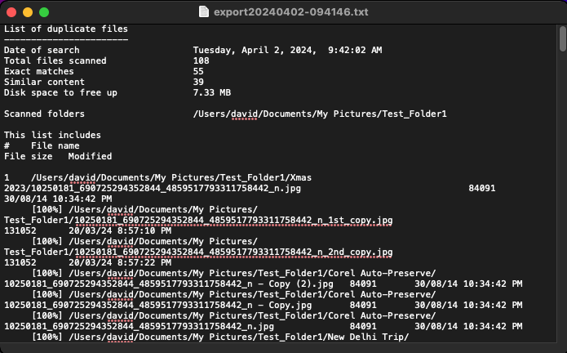

**Figure 20: Scan result details exported as a Text file**

* **Export to CSV –** Clicking this option enables you to export selected file details as a Comma Separated Values (CSV) file. Once you have exported the selected file details as an CSV file, after opening the CSV in your MS Excel application, the output includes key details of the scan along with a table depicted both original files listed with their duplicates as depicted in the figure below –

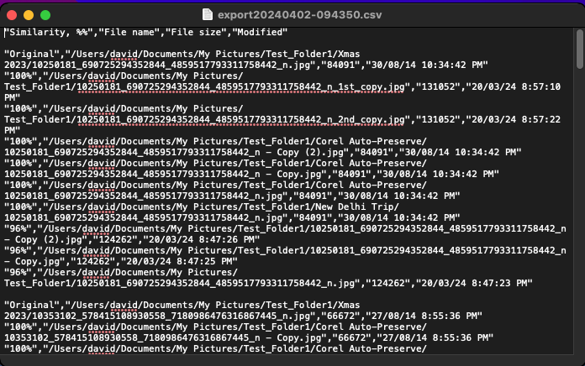

**Figure 21: Scan result details exported as a CSV file**

* **Export to HTML –** Clicking this option enables you to export selected file details as a Hyper Text Markup Language (HTML) file. Once you have exported the selected file details as an HTML file, after opening the HTML file in your default web browser the output includes key details of the scan along with a table depicted both original files listed with their duplicates as depicted in the figure below –

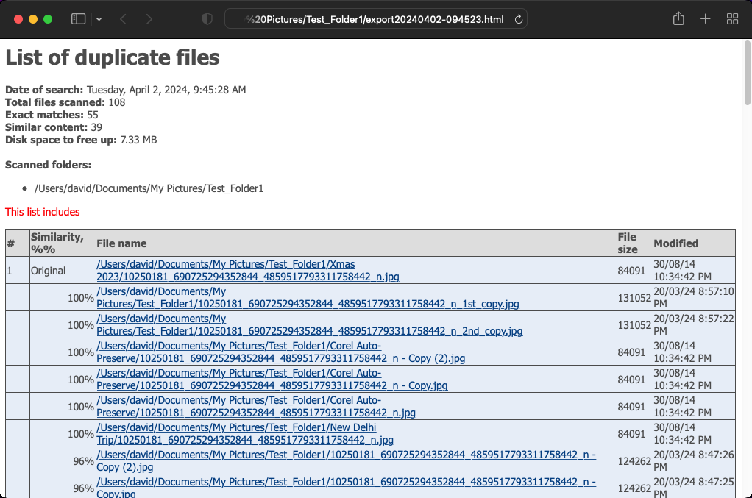

**Figure 22: Scan result details exported as an HTML file**

* **Export to XLS –** Clicking this option enables you to export selected file details as a Microsoft Excel file. Once you have exported the selected file details as an XLS or MS Excel file, after opening this file in MS Excel, the output includes key details of the scan along with a table depicted both original files listed with their duplicates as depicted in the figure below –

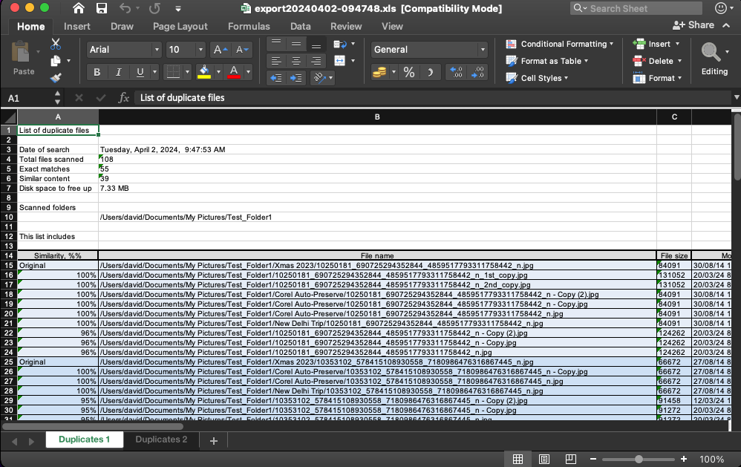

**Figure 23: Scan result details exported as an XLS file**

* **Save Scan –** Clicking this option saves the displayed scan results file as a scan data file. The scan data file format is proprietary to Duplicate Photo CleanerTM application and its product owners. While the Export types are consumable by the end users of this application as indicated in the previous points, the scan data file can only be consumed by the Duplicate Photo CleanerTM application directly. i.e., we can only view the contents of the scan data file after it has been imported into the DPC application using the Import a scan option.

**Tip:** For more information on importing a scan, refer to **Importing a Scan** section.

### Clearing the Displayed Scan Results from Scan Results page

This sub-section describes the two types of scan results clearing operations that you can perform on the scan results page as depicted in the figure below –

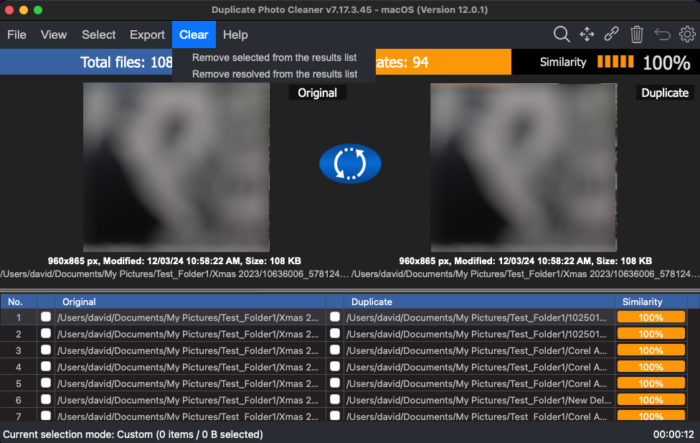

1. **Remove selected from the results list –** Clicking this option removes the selected files from the scan results list
2. **Remove resolved from the results list –** Clicking this option removes the resolved files from the scan results list

### Using the Mouseover Menu on the Image Preview

When you are previewing any image original or duplicate on the scan details page, hovering your mouse cursor over the image preview available on the scan details page, the mouseover menu is displayed as depicted in the figure below –

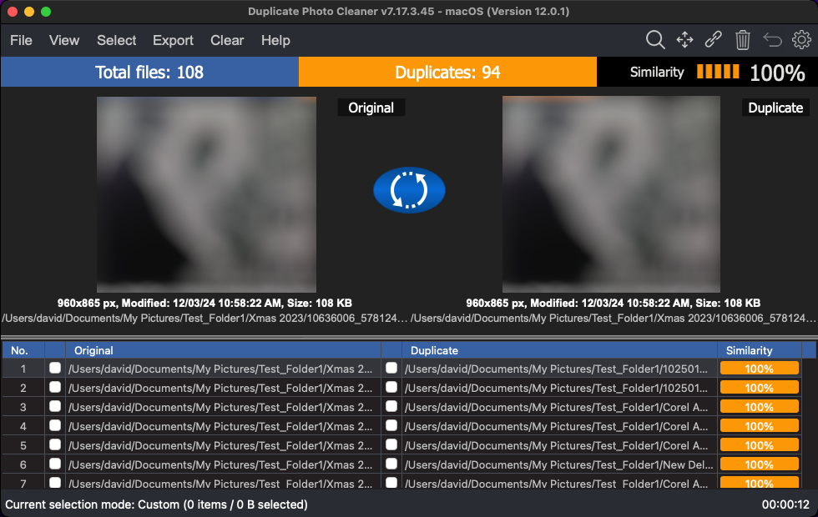

Here is a description of the actions you can perform using the buttons available on this menu –

* **Move –** Clicking this button opens the Move to Folder popup.

**Reference:** For more information, refer to **Performing a Move Duplicates Action** section.

* **Preview –** Clicking this button opens the Preview screen and displays this file.
* **Delete –** Clicking this button opens the Delete selected popup which enables you to delete this file.

**Reference:** For more information, refer to **Performing a Delete Duplicate Photos Action** section.

### Scan Detail Page Actions Menu Descriptions

While performing the 7 types of scans that the macOS based Duplicate Photo CleanerTM application performs, this section describes the scan detail page actions menu. This actions menu provides buttons for specific functions that are described in the following sub-sections and depicted in the figure below –



Figure 24 – Scan Details Page Action buttons

| **BUTTON** | **BUTTON NAME** | **DESCRIPTION** |
| --- | --- | --- |
|  | **Search** | Clicking this button enables you to Search the within the original and duplicate photos listed on the scan details page.  **Reference:** For a detailed information on this button, refer to Performing a Search / Filter Duplicates Action section. |
|  | **Move** | Clicking this button enables you to Move duplicate photos as listed on the scan details page to a folder of your choice.  **Reference**: For a detailed information on this button, refer to Performing a Move Duplicates Action section. |
|  | **Link** | Clicking this button enables you to replace duplicate photos with symbolic links to the original photo as listed on the scan details page.  **Reference**: For a detailed information on this button, refer to Performing a Link Duplicate Photos to Original Photos Action section. |
|  | **Delete** | Clicking this button enables you to Delete selected duplicate photos as listed on the scan details page.  **Reference**: For a detailed information on this button, refer to Performing a Delete Duplicate Photos Action section. |
|  | **Undo** | Clicking this button enables you to Undo your previous actions that you perform on the duplicate photos listed on the scan details page.  **Reference**: For a detailed information on this button, refer to Performing an Undo Action section. |
|  | **Settings** | Clicking this button enables you to open the settings panel of DPC.  **Reference**: For a detailed information on this button, refer to Opening the Settings Panel section. |

Performing a Search / Filter Duplicates Action

Consider a scenario where in you performed a Standard Scan, say for example, and then you want to search for duplicates of a specific photo. In this case you can click the Search button from Scan Detail Page Actions Menu on the top right-hand corner scan details page. The Search / Filter Duplicates popup is displayed as depicted in the figure below –

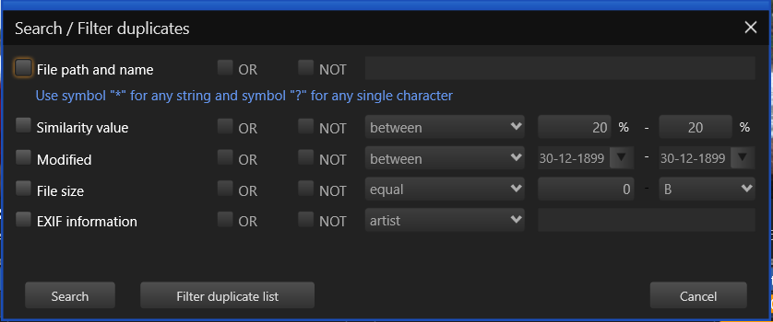

Figure 25 – Search / Filter duplicates popup

Using this popup you can perform the following searches –

* By Filter path and name
* By Similarity value
* By Modified (Date)
* By File size
* By EXIF information

Searching by Filter path and name

The steps below enable you to search for duplicates by filter path and name –

1. Click the **File path and name** checkbox. The sub-options displayed to right of this checkbox will be enabled as depicted in the figure below –

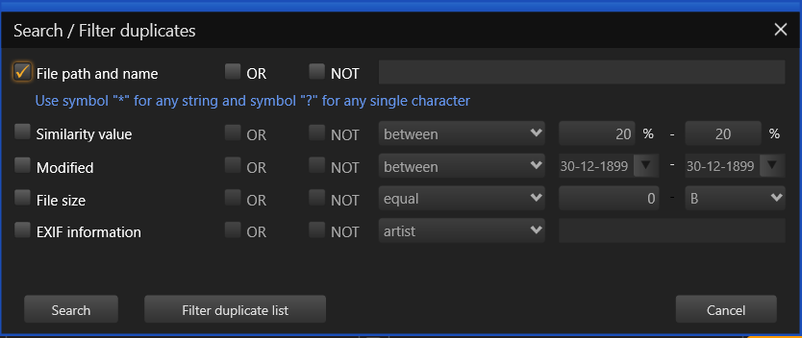

Figure 26 – Search / Filter duplicates by file path and name

1. Now let us try to remove specific duplicates from the duplicate photos list (and not the folder) by specifying the most common string in all the related duplicate photo filenames.
2. In our test case, let’s say we intend to remove all duplicates from the duplicate photo list (and not from their folders) which match the string “Uncle Jaswant & Aunty Neelam” as this search / filter string is common in the original and the group of its duplicates.

**Tip:** Using wildcard symbols * and ? can help us specify our search string accurately. The * wildcard symbol indicates any one or more characters while ? wildcard symbol signifies only one character.

1. To do so, we can specify * before my search string “Uncle Jaswant & Aunty Neelam” which would mean that the file path as well as the filename is signified by the first * wildcard symbol while when we use this * symbol after the search string then the filename can have any number of characters after the search string. i.e., our complete search string become as indicated below –

**\*Uncle Jaswant & Aunty Neelam\***

1. Now let us go ahead and type this in the search string text field provided as depicted in the figure below –

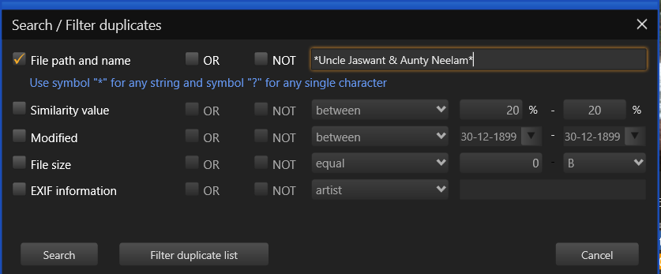

Figure 27 – Specifying the search string along with the wildcard * symbol

1. Notice if you select the OR checkbox here and then you click **Filter duplicate list** then there is no change to the duplicate photo list. This is because the duplicate list already contains all duplicates of the related original both with and without this search string text.
2. But in case we use the NOT checkbox, then the duplicate photos with the specified search string will be removed from the duplicate photos list as depicted in the figure below –

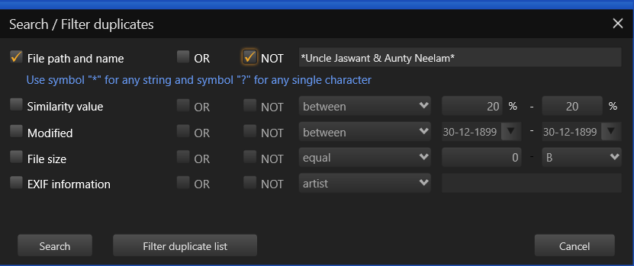

Figure 28 – Specifying the NOT checkbox

1. Now when we click **Filter** **duplicate list** then all duplicate photos matching the specified search / filter criteria will be removed from the duplicate photos column.

By Similarity value

While performing the standard scan on my Test Folder I had specified a Similarity percentage of 75%. But after the scan completed, the scan details page shows duplicates with multiple similarity percentages. Now let’s say I want to find if any of the photos have a similarity percentage between 20% and 99%.

Here’s how we can specify that using the Search / Filter popup –

1. So now picking up from the freshly performed standard scan, let us click the Similarity value checkbox. The adjacent options are enabled as depicted in figure below –

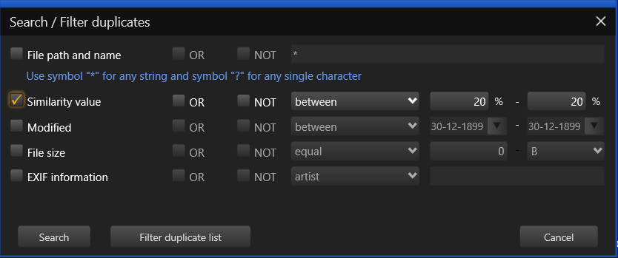

Figure 29 – Search / Filter duplicates by similarity value

**Tip:** After you make selections on this popup you can choose to let this popup persist on the screen. To do so, click **Search** but in case you intend to close this popup and view the searched / filtered results, then you can click **Filter duplicate list.**

1. Let us specify between 20% and 99% to check if any duplicate photo identified by DPC is lesser in similarity value than 100%.
2. To do so, click the between drop down and select between option and then specify 20% in the first percentage specification box and 99% in the second percentage specification box.

**Tip:** If you place your mouse cursor over the first similarity percentage specification box and then you keep the left button of your mouse pressed and you move the mouse to the left then you can see the percentage value decreasing from the current value. But since we cannot specify any similarity value lesser than 20% nothing will happen here. But let us try this same action on the second percentage specification box. But this time let us move our mouse cursor to the right after we keep the left mouse button pressed. We will notice that the value starts increasing post 20%.

1. Let us specify the 99% similarity value in the second percentage specification box.
2. Thus, our search / filter criteria is –

Similarity Value between 20% and 99%

1. Now click the **Filter duplicate list**. All duplicate photos with the similarity percentage value of 100% are removed from the duplicate photos list as depicted in the figure below –

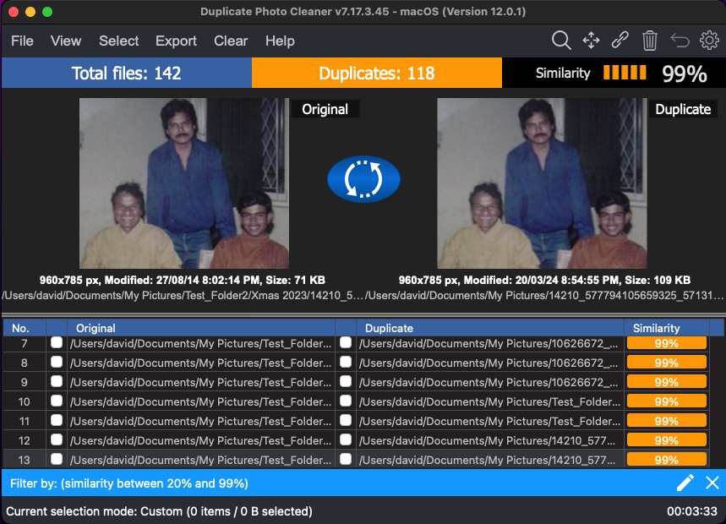

Figure 30 – Search / Filter duplicates by similarity value between 20% and 99%

Similarly, we can also use the OR and NOT checkboxes as described in the previous sub-section.

By Modified (Date)

You can utilize the same logic described in the By Similarity Value sub-section for the modified date checkbox as well.

By File size

You can utilize the same logic described in the By Similarity Value sub-section for the file size checkbox as well.

By EXIF information

You can utilize the same logic described in the By Similarity Value sub-section for the EXIF information checkbox as well. The minor difference being that the logic drop-down lists all EXIF meta data options like artist, author. You can select any one of them at a time and then specify a search / filter string with or without the wildcard * or ? symbols to develop your own search / filter criteria.

**Note:** By now we have done most of the logical operations like OR, NOT, equal to, between, less than, larger than, etc. except one – The AND logical operation. This is where you will see than that you can select multiple checkbox criteria on the Search / Filter duplicates popup and then the AND logical operand concatenates or joins two or more search filter criteria. Notice that on step 4 of performing these actions you can see the filter criteria that you have specified. This is where you can evaluate the logic that DPC will utilize while Searching / Filtering duplicate photos basis your composite Search / Filter criteria. E.g., Similarity value equal to 100% AND Modified between Date1 and Date 2.

Performing a Move Duplicates Action

Consider a scenario where in you performed a Standard Scan, say for example, and then you intend to move all duplicates with similarity percentage less than 100% to a separate folder. In this case you can click the Move button from Scan Detail Page Actions Menu on the top right-hand corner scan details page. The Search / Filter Duplicates popup is displayed as depicted in the figure below –

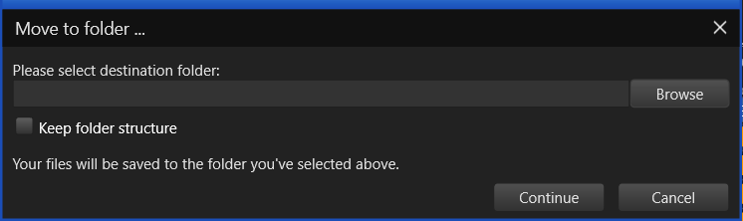

Figure 31 – Search / Filter duplicates popup

**Warning:** In case you have not selected any duplicate files, DPC will display a popup stating that nothing is selected.

So let us retrace our steps a few steps behind. Perform the standard scan (or any other scan as per your choice) and reach the scan details page as depicted in the figure below –

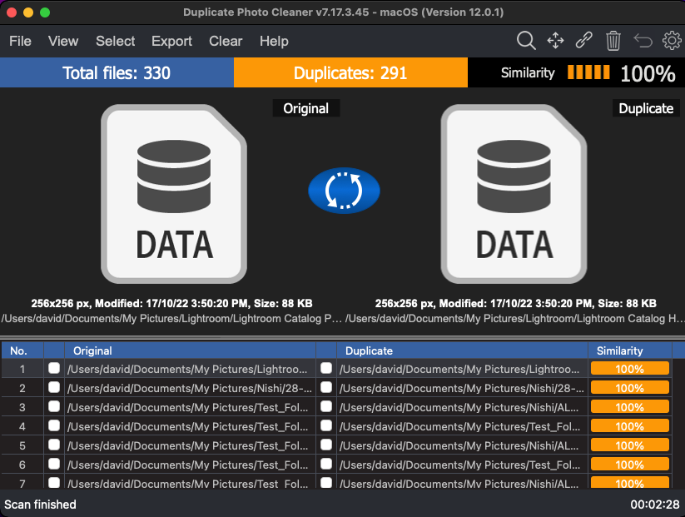

Figure 32 –Scan Details page

Here’s how we can approach our requirements –

First, let us isolate all duplicate photos with similarity value percentage as 100%. And then we can perform the Move action on the isolated duplicate photos with similarity percentage equal to 100%.

Here are the steps that enable you to do so –

1. From the Select menu, click the **Select duplicates** option. All duplicate photos will be selected.
2. Now let us utilize the Search / Filter popup to isolate all duplicate photos with similarity percentage value as 100%. To do so, click **Search** from the Scan details page action menu on the top right-hand corner of the screen. The Search / Filter popup is displayed.
3. Using this popup specify Similarity value equal to 100% as depicted in the figure below –

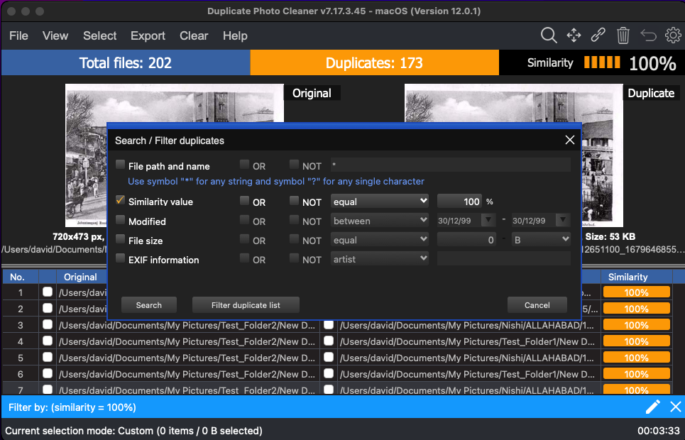

Figure 33 –Scan Details page – all duplicates selected – Search / Filter popup

1. Click **Filter duplicate list**. All duplicate photos with the Similarity percentage value equal to 100% will remain and all other duplicate photos with this value lesser than 100% will be revied from the duplicate photos list as depicted in the figure below –



Figure 34 –Scan Details page – all duplicates with Similarity percentage value equal to 100%

**Tip:** To revisit or change your search / filter criteria, click the **pencil icon** as indicated by the red arrow in the figure above. This will open Search / Filter duplicates popup.

1. Since these duplicate photos are already selected, click **Move** from the scan details page actions menu available on the top right-hand corner of the screen. The Move to Folder popup will be displayed as depicted in the figure below –

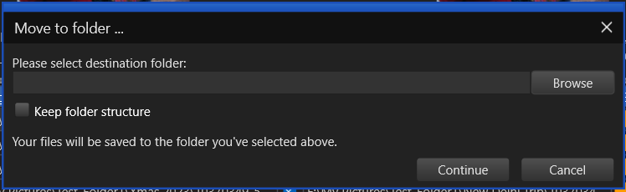

Figure 35 – Move to Folder popup

1. Click **Browse** to specify a folder location of your choice and click **Continue**.

**Tip:** In case there are sub-folders within this folder which contain duplicate photos, select the Keep folder structure checkbox to retain the folder structure after these duplicate photos are moved.

1. After you click **Continue**, the duplicate photos with similarity value equal to 100% that we isolated will be moved to the folder you specified. And, thus they will be removed from the current duplicate photos list.

**Tip:** Click **Cancel** to abort recipient folder specification action. The recipient folder is the folder to which your selected duplicate folder would be moved to.

Performing a Link Duplicate Photos to Original Photos Action

By definition, a symbolic link is a link to a file or directory on the same or different volume (drive letter) or even to a remote file or directory (using universal naming convention or UNC in its path).

Consider a scenario where in you performed a Standard Scan, say for example, and then you intend to link all duplicates as symbolic links to the original photo. In this case here is how we can to do –

1. First, let us select all the duplicate photos. To do so, click **Select** duplicates from the Select Menu. All duplicate photos will be selected on the scan details page as depicted in the figure below –

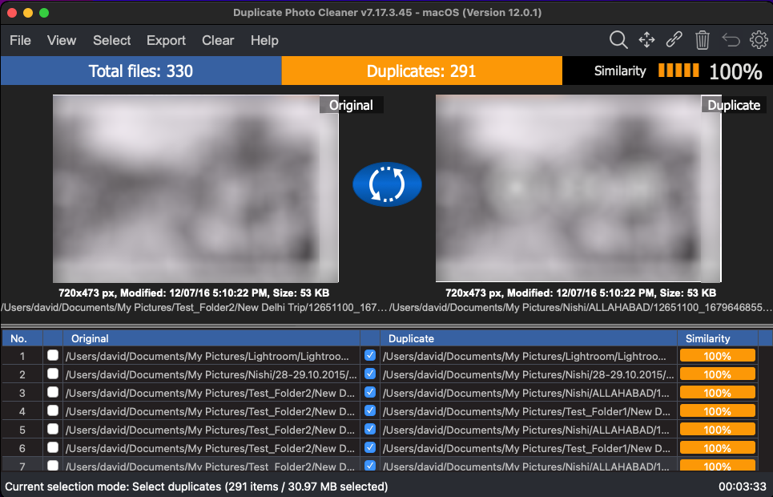

Figure 36 – Selecting all duplicate photos on the scan details page

1. Click the **Link** button from Scan Detail Page Actions Menu on the top right-hand corner scan details page. A confirmation message popup is displayed as depicted in the figure below –

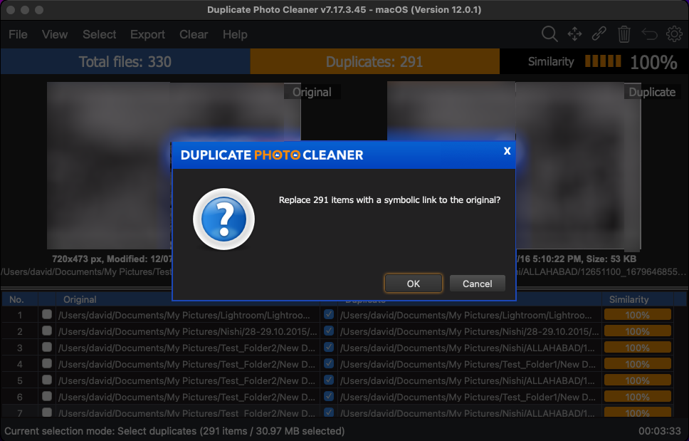

Figure 37 – Link menu options – Symbolic link

1. Click **OK** to continue replacing the duplicate photos with symbolic links or you can click **Cancel** to abort this action.

To the end user a symbolic link functions in the same way the original photo of such a link would behave but this ultimately results in optimization of storage space & alleviates duplicity of photos across multiple folders.

**Tip:** In case you encounter an error while performing the linking operation, the Duplicate Photo CleanerTM application will direct you to view the log file which you can access by clicking the **Settings** button and then after you navigate to the **Logging** tab on the Settings panel, click **Open logs** as depicted in the figure below –

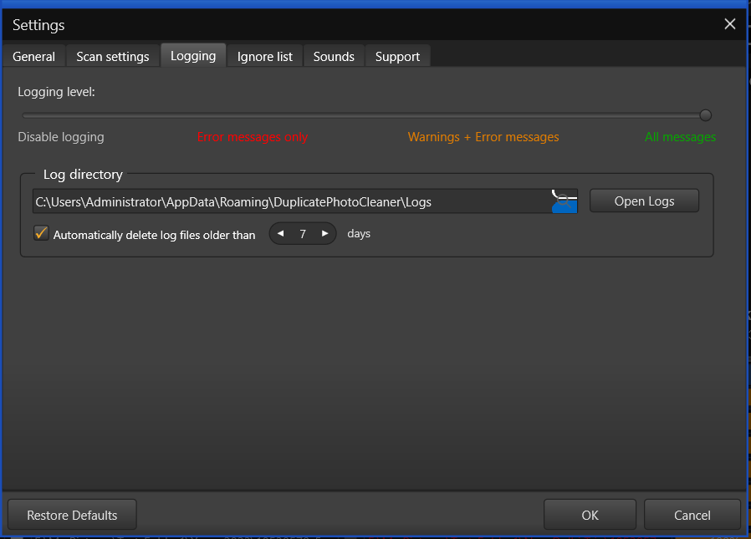

Figure 38 – Viewing the log file after encountering an error

Performing a Delete Duplicate Photos Action

Consider a scenario where in you performed a Standard Scan, say for example, and then you intend to delete all duplicates photos.

Here are steps that enable you to delete the duplicate photos –

1. After you click the **Go Fix Them** button on the scan summary details page, the scan details page is displayed as depicted in the figure below –

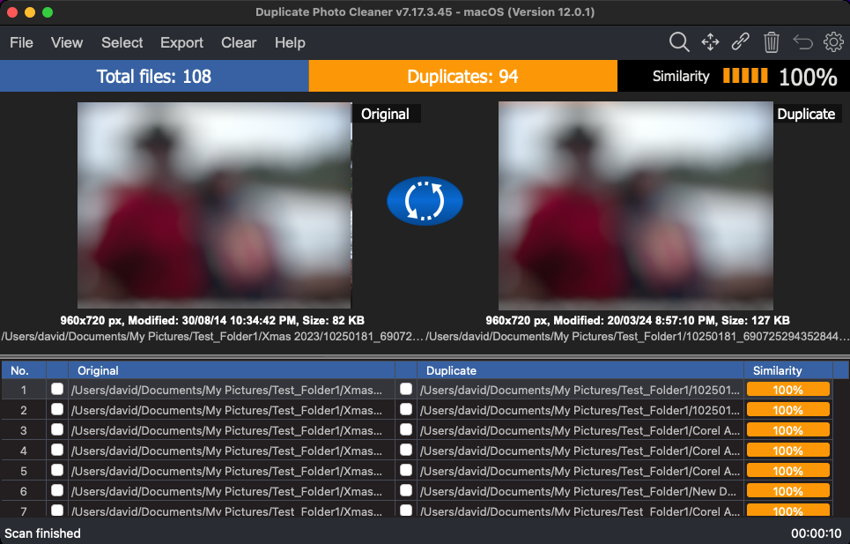

Figure 39 –Scan Details page

**Warning:** As a best practice, always backup your photo files & folders before you perform any such operation.

1. Click **Select**, then click **Select duplicates** from the Select menu. The duplicate photos are selected as depicted in the figure below –

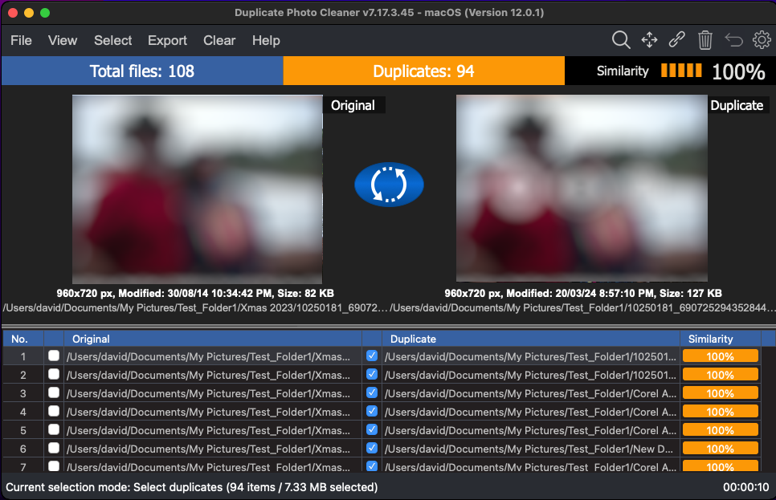

Figure 40 –Scan Details page – Selected all duplicate photos

1. Now from the Scan Details page action menu available on the top right-hand corner of the screen, click the **Delete** button. The Delete selected popup is displayed which prompts you to specify your choice by selecting between moving the files to trash bin or to permanently delete these files as depicted in the figure below –

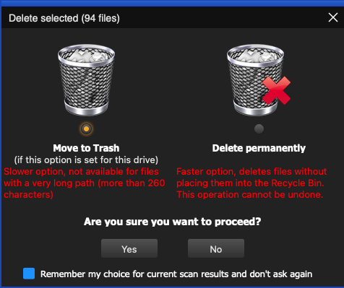

Figure 41 –Scan Details page – Selected all duplicate photos

1. Specify your choice and click **Yes**. All duplicate photos are moved to trash as depicted in the figure below –

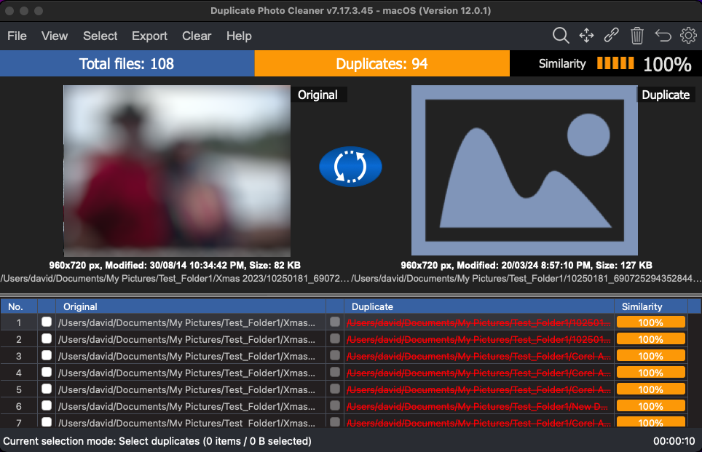

Figure 42 –Scan Details page – deleted all duplicate photos as per your selection

**Tip:** It is important to note here that if you selected the **Move to Trash** operation then you will be able to undo this operation. But in case you selected the **Delete permanently** option then you cannot undo this operation.

Performing an Undo Action

The Duplicate Photo CleanerTM application provides the Undo action feature using which you can undo all actions which are reversable and done in a sequence without a new scan being performed in this sequence. i.e., the user can perform unlimited Undo actions if no new scan is performed or no irreversible action has been performed in the sequence of actions. An example has been shared in the Tip above.

Consider a scenario in which we intend to perform multiple tasks with the identified duplicate photos in the below fashion –

1. First, we isolate all duplicate photos with similarity percentage value between **90% and 94%** and we intend to **delete these duplicate photos permanently**.
2. Then, we intend **to move all duplicate files** with similarity percentage value between **95% and 99%** to a separate folder of our choice.
3. And finally, we **move all duplicate photos to recycle bin** with similarity percentage value **equal to 100%**.

**Warning:** Consider in the above example, if we **delete all duplicate photos permanently** instead of **moving them to trash**, then the whole Last-In-First-Out (LIFO) Undo Actions Stack is lost as the First Out step itself is irreversible. In other words, only a sequence of unlimited reversible actions can be undone so long as a new scan performed.

Now after we have performed the actions in steps 1 through 3, try to undo these actions one by one by clicking the Undo button from the Scan Details page actions menu. Each of these actions will be reversed successfully.

**Reference:** Refer to previous sub-sections to perform steps 1 through 3.

Opening the Settings Panel

The settings panel includes all general features which are applicable to specific areas of the Duplicate Photo CleanerTM. On a case-to-case basis after you perform any of the scan types, you may require to switch on / off one or more features of the Duplicate Photos CleanerTM application. E.g., Disable protection against accidental deletion of all files in a group of duplicates, Or Safe reverse selection (avoid selecting all elements in a group), Cumulative selection, etc.

Click the **Settings** button on the Scan Details Page Actions menu available on the top right-hand corner of the screen on the Scan Details Page Action menu available on the scan details page. The Settings panel is displayed as depicted in the figure below –



Figure 43 – The Settings Panel

**Reference:** For a detailed description of the Settings Panel, refer to **The Settings Panel Detailed Description** section.

The next chapter describes steps that enable you to **Register your DPC Application Installation**.

# Registering your DPC Application Installation

The steps described below enable you to place a **Buy Now** request of the Duplicate Photo CleanerTM application via the Duplicate Photo CleanerTM homepage –

You can place a **Register** request in the following 2 ways –

## Via the DPC Homepage

The steps described below enable you to register the DPC application via the DPC homepage –

1. From the DPC application homepage, click the **Support > Register Your Product** link available in the menu on the DPC TM homepage as depicted in the figure below –

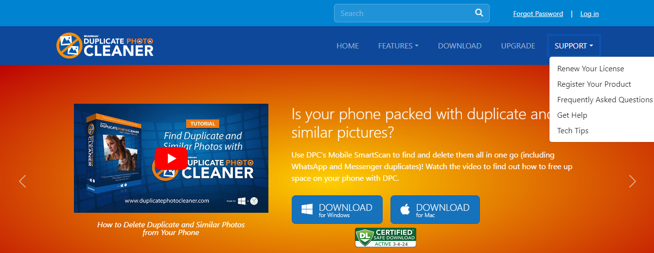

Figure 44 – Registering your DPC application installation via the DPCTM homepage

1. Click **Register** as depicted in the figure above. The register your software form is displayed as depicted in the figure below –

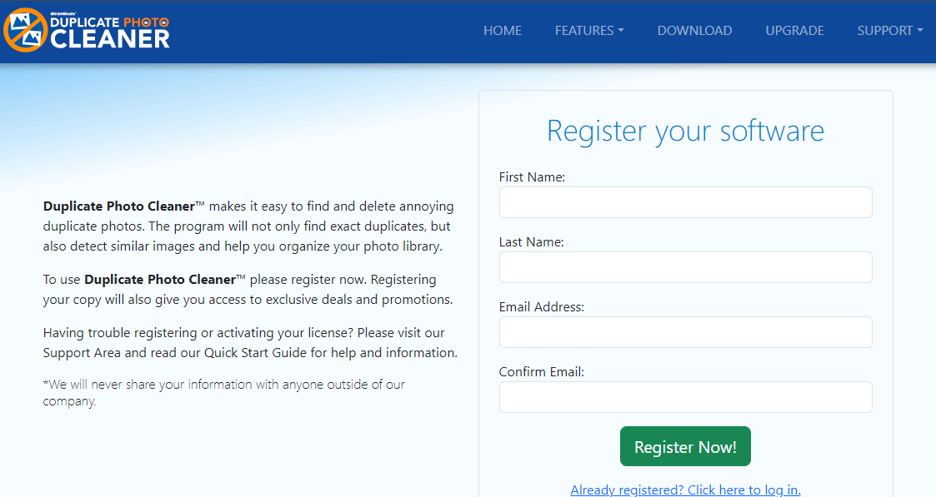

Figure 45 – Specifying your registration details

**Tip:** In case you have already registered, click the corresponding link provided under the **Register Now!** Button.

1. Specify your first name, last name, your email address, then confirm your email address & click **Register Now!** The secure cart checkout page is displayed as depicted in the figure below –

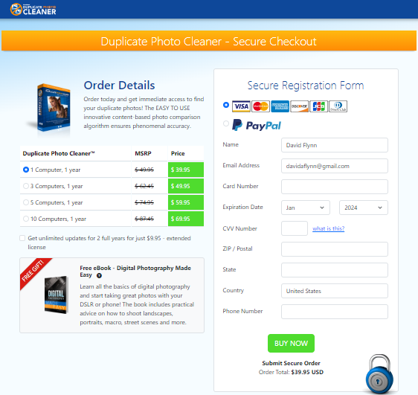

Figure 46 – Secure Registration page

1. Specify the required license options and your payment details & click **Buy Now**.

**Warning:** Ensure to double-check your specified details before you click **Buy Now**.

1. Once your payment details have been successfully processed, you will receive an email containing your DPCTM license key.

## Via the Register Button of DPC Application

The steps described below enable you to register the DPC application via the Register Button of DPC application –

1. After you launch the DPC application, the default screen is displayed as depicted in the figure below –



Figure 47 – DPC application default page

1. From the main toolbar menu, click **Help > About**. The DPC Product Key Details popup is displayed as depicted in the figure below –

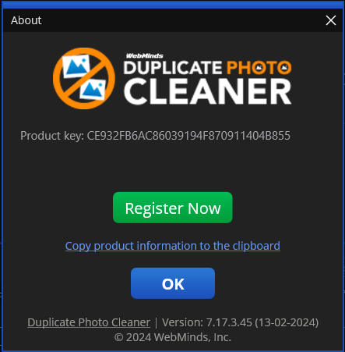

Figure 48 – DPC application license key specification – step 1

1. Click the **Register Now** button as depicted in the previous figure. The license registration key popup is displayed as depicted in the figure below –

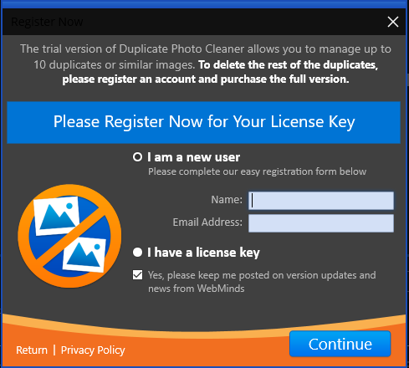

Figure 49 – DPC application license key specification – step 2

1. Specify your **Name** & **Email Address** and click **Continue**. You will receive your license details via email shortly. Also, the license registration key popup is displayed as depicted in the figure below –

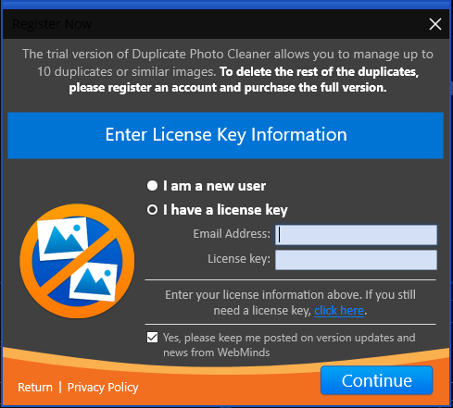

Figure 50 – DPC application license key specification – step 3

**Tip:** In case you haven’t received your license yet, you can close this popup and continue exploring the DPC application. Once you receive your license details, follow the steps described in **Activating your DPC Installation** chapter.

1. If you have received your license details, specify your **Email Address** & **License Key** and click **Continue**. Your license key will be validated with our records and a successful activation popup message will be displayed also confirming a successful registration as depicted in the figure below –

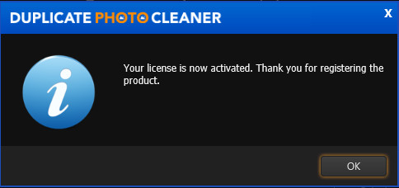

Figure 51 – DPC application license key activation successful

1. Click **OK** to continue. Now the 10-item duplicate photo limit will be removed and you can utilize all features of this application freely without any limitations.

The next chapter describes steps that enable you to **Activate your DPC Application**.

# Activating your DPC Installation

In case you have not activated your Duplicate Photo CleanerTM application yet, you can utilize the steps described below –

1. After you launch the DPC application, the default screen is displayed as depicted in the figure below –



Figure 52 – DPC application default screen

1. From the main toolbar menu, click **Help > About**. The DPC Product Key Details popup is displayed as depicted in the figure below –



Figure 53 – Activating DPC application – step 1

1. Click the **Register Now** button as depicted in the previous figure. The license registration key popup is displayed as depicted in the figure below –



Figure 54 – Activating DPC application – step 2

1. Select the **I have a license key** radio button. The license activation popup view is changed as depicted in the figure below –

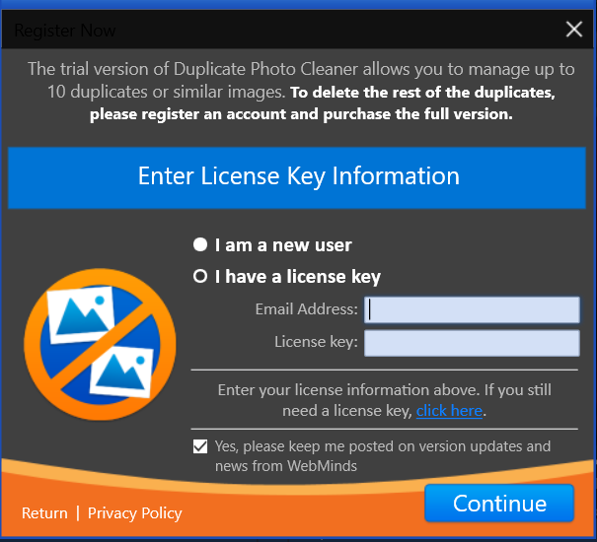

Figure 55 – Activating DPC application – step 3

1. Specify your **Email Address** & **License Key** and click **Continue**. A successful license key activation message popup is displayed also confirming that the registration has also been successful as depicted in the figure below –



Figure 56 – DPC application license key activation successful

1. Click **OK** to continue. Now the 10-item duplicate photo limit will be removed and you can utilize all features of this application freely without any limitations.

The next chapter describes steps that enable you to **Entering a New Key**.

# Entering a New Key

In case your existing license key has expired and you have received a new key post the successful purchase of a new key, you can enter this new key by utilizing the steps described below –

1. After you launch the DPC application, the default screen is displayed as depicted in the figure below –



Figure 57 – DPC application default screen

1. From the main toolbar menu, click **Help > About**. The DPC Product Key Details popup is displayed as depicted in the figure below –

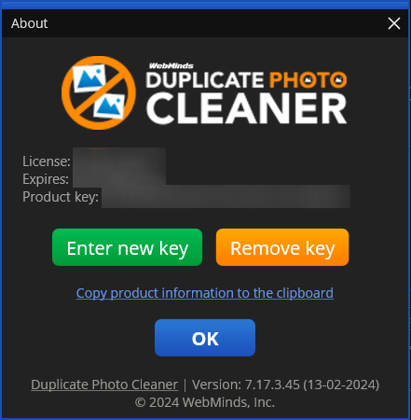

Figure 58 – Removing DPC application license key details – About popup

1. Click the **Enter new Key** button as depicted in the previous figure. The license registration key popup is displayed as depicted in the figure below –



Figure 59 – Activating DPC application – step 2

1. Select the **I have a license key** radio button. The license activation popup view is changed as depicted in the figure below –



Figure 60 – Activating DPC application – step 3

1. Specify your **Email Address** & **License Key** and click **Continue**. A successful license key activation message popup is displayed also confirming that the registration has also been successful as depicted in the figure below –



Figure 61 – DPC application license key activation successful

1. Click **OK** to continue. Now the 10-item duplicate photo limit will be removed and you can utilize all features of this application freely without any limitations.

The next chapter describes steps that enable you to **Remove your DPC License Key details**.

# Removing your DPC License Details

In case you intend to remove your DPC application license details so that you can use it on another system, you can utilize the steps described below –

**Warning:** You can only activate & remove your DPC license details 3 times post which this license will automatically expire.

1. After you launch the DPC application, the default screen is displayed as depicted in the figure below –



Figure 62 – DPC application default screen

1. From the main toolbar menu, click **Help > About**. The DPC Product Key Details popup is displayed as depicted in the figure below –



Figure 63 – Removing DPC application license key details – About popup

1. Click the **Remove Key** button as depicted in the previous figure. The license key removal confirmation popup is displayed as depicted in the figure below –



Figure 64 – Removing license key details confirmation popup

1. Click the **Yes** button. A successful license key removal confirmation messages is displayed as depicted in the figure below –



Figure 65 – Successful Removal of DPC application license key details

1. Click **OK** to continue. Now you can reuse this license key on another computer.

**Warning:** You can only activate & remove your DPC license details 3 times post which this license will automatically expire.

The next chapter describes steps that enable you to **Perform a Standard Scan**.

# Performing a Standard Scan

In today’s world most of us are busy collecting memories via SLR Cameras & Smartphones. Little do we realize that even though storage space is cheap it does require some effort in its maintenance. Performing this maintenance becomes a time-consuming chore especially when we use the burst mode in both these afore mentioned devices. Thus, we are prone to having duplicate images / photos of the same photo profile. E.g., the photo of the flight of an eagle, the photo of two elephants dueling during the mating season, etc. It is in situations like these that the Duplication Photo CleanerTM application enables you to quickly scan for duplicate images and photos and optimize your photo library.

The steps described below enable you to perform a Standard Scan –

1. After you launch the Duplicate Photo CleanerTM application, the default screen is displayed as depicted in the figure below –

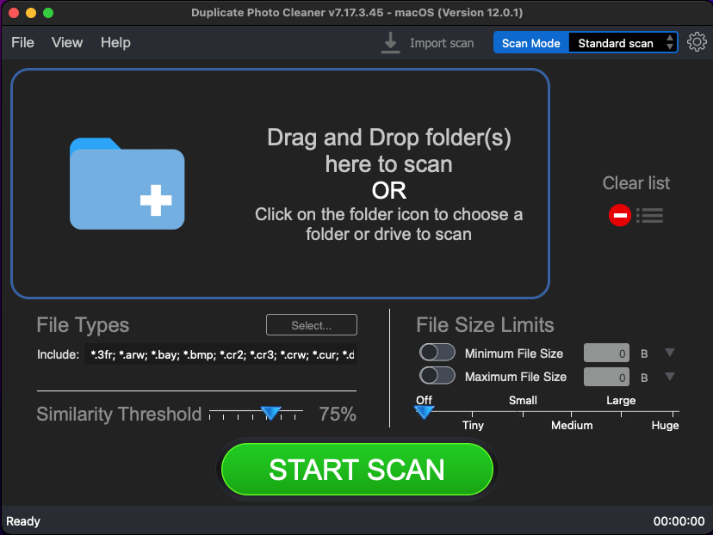

Figure 66 – Performing a Standard Scan – DPC default screen

Below are the functions along with a description of the parameters that you can tweak before you start a standard scan –

* + **Select folder –** Clicking on the blue folder icon or by dragging a folder and dropping it in the area as depicted in the figure above, enables you to select a target folder which is to be scanned
  + **Clear List –** Clicking this button clears the target folder list
  + **File Types –** Clicking the Select button in this area as depicted in the figure above enables you to specify which file types are to be scanned for duplicates
  + **File Size Limits –** Specifying the maximum & minimum file sizes enables you to specify the size range of the files to be scanned. You can switch on the maximum & minimum limit applicability by swiping the slider button from left to right. Then you can specify the numerical values for both maximum & minimum limits and select the adjacent drop-downs to specify whether the limits must be considered in bytes (B), kilobytes (KB), megabytes (MB), or gigabytes (GB). After you specify the values in the fields described above, you will notice that the slider below changes to depict the whether the limits chosen signify Tiny, Small, Medium, Large, or Huge. Conversely, you can also use this slider instead of specifying the maximum & minimum limits
  + **Similarity Threshold –** You can utilize this slider to set the similarity threshold percentage which is to be set while searching for duplicate images

1. Click the blue folder icon or drag & drop a target folder that you intend to scan. The specified folder is selected and listed in target folder list as depicted in the figure below –

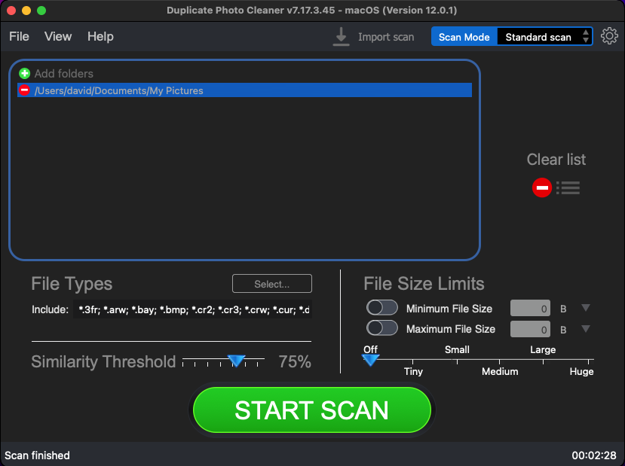

Figure 67 – Selecting one or more folders

**Tip:** You can add more folders in the target folder list by clicking the green Add folders button as depicted in the figure above.

1. Specify the scan parameters as per your discretion and click Start Scan. Once the scan is finished, the scan results summary page is displayed as depicted in the figure below –

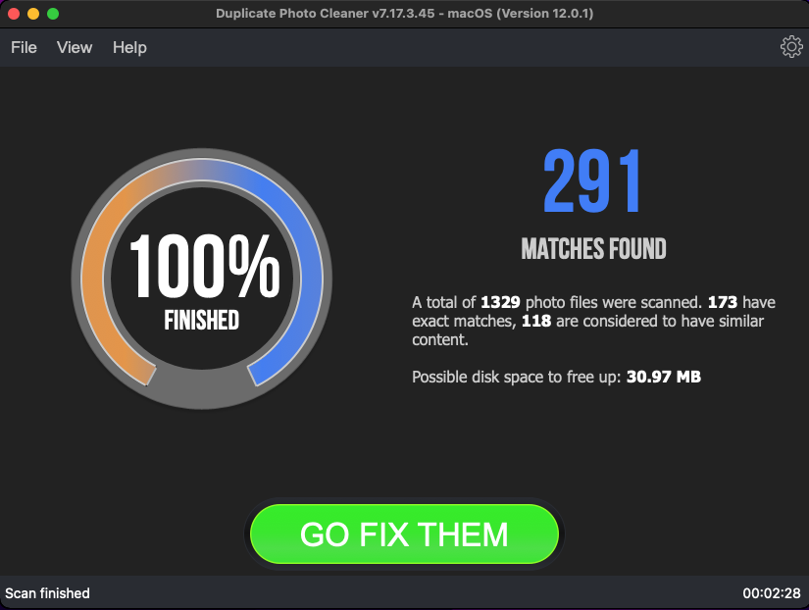

Figure 68 – Scan results summary page

1. Click **GO FIX THEM**. The scan results page is displayed as depicted in the figure below –



Figure 69 – Scan results details page

**Reference:** To save this scan, refer to Saving a Scan section. To import this scan later, refer to Importing a Scan section.

**Reference:** To perform multiple types of selections, refer to Viewing Modes Available for the Results on the Scan Details page section.

**Reference:** To export your scan results details as a file, refer to Exporting your Scan Result Details as a File section.

**Reference:** To clear the displayed scan results, refer to Clearing the Displayed Scan Results from Scan Results page section.

**Tip:** You can also click the Swap Images button available between the displayed original and duplicate image on screen in case you intend to keep the duplicate file while doing away with the original.

1. After you have selected the duplicate files that you intend to delete or move or in case you intend to replace the duplicate files with symbolic links, from the top right-hand corner on the scan results page, click the corresponding buttons as depicted in the figure below –



Figure 70 – Scan Details Page Actions Menu

**Reference:** Refer to **Scan Detail Page Actions Menu Description** section for a detailed description of the buttons available on the Scan Details Page Actions Menu.

The next chapter describes steps that enable you to **Perform a Folder Comparison**.

# Performing a Folder Comparison

While creating multiple albums, we may end up including the same photos or their duplicates in multiple albums. In such a scenario often, we find encounter duplicate photos which occupy storage space unnecessarily. Now it would make sense to remove such duplicate photos but a better resolution of such images would be to perform a folder comparison and link the duplicate photos as symbolic links. In this way we free up precious storage space and yet retain the file in the original folder and the symbolic link in the other folder.

The steps described below enable you to perform a Folder Comparison –

1. After you launch the Duplicate Photo CleanerTM application, the default screen is displayed as depicted in the figure below –



Figure 71 – Performing a Folder Comparison scan – DPC default screen

1. From the top right-hand corner click the Scan Mode drop-down and select the Folder Comparison option. The Folder Comparison page is displayed as depicted in the figure below –

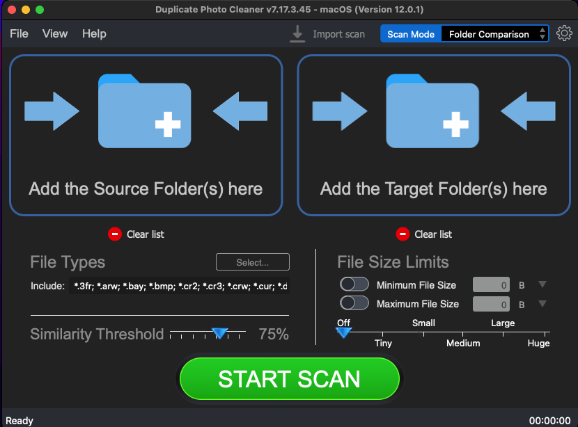

Figure 72 – Selecting the Folder Comparison option

1. Select the Source and the Target Folders by clicking the corresponding blue folder icons

Below are the functions along with a description of the parameters that you can tweak before you start a standard scan –

* + **Select folder –** Clicking on the blue folder icon or by dragging a folder and dropping it in the corresponding area as depicted in the figure above, enables you to select a source as well as a target folder which is to be scanned
  + **Clear List –** Clicking the corresponding button clears the source and target folder lists
  + **File Types –** Clicking the Select button in this area as depicted in the figure above enables you to specify which file types are to be scanned for duplicates
  + **File Size Limits –** Specifying the maximum & minimum file sizes enables you to specify the size range of the files to be scanned. You can switch on the maximum & minimum limit applicability by swiping the slider button from left to right. Then you can specify the numerical values for both maximum & minimum limits and select the adjacent drop-downs to specify whether the limits must be considered in bytes (B), kilobytes (KB), megabytes (MB), or gigabytes (GB). After you specify the values in the fields described above, you will notice that the slider below changes to depict the whether the limits chosen signify Tiny, Small, Medium, Large, or Huge. Conversely, you can also use this slider instead of specifying the maximum & minimum limits
  + **Similarity Threshold –** You can utilize this slider to set the similarity threshold percentage which is to be set while searching for duplicate images

1. Click the blue folder icon or drag & drop a target folder that you intend to scan. The specified folder is selected & listed in target folder list as depicted in the figure below –

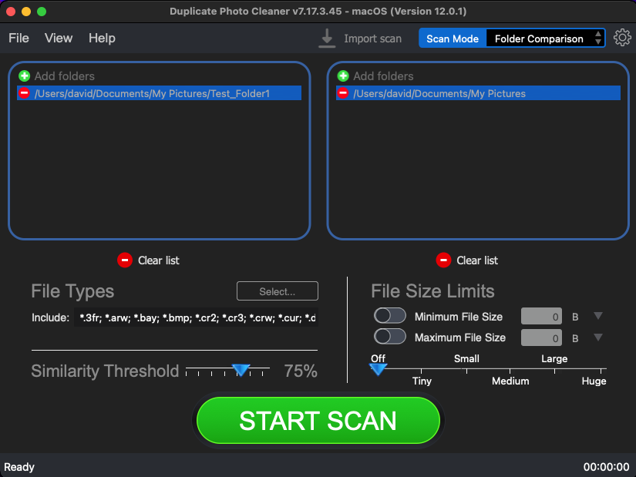

Figure 73 – Selecting one or more source & target folders

**Tip:** You can add more folders in the source and target folder list by clicking the corresponding green Add folders button as depicted in the figure above.

1. Specify the scan parameters as per your discretion and click Start Scan. Once the scan is finished, the scan results summary page is displayed as depicted in the figure below –

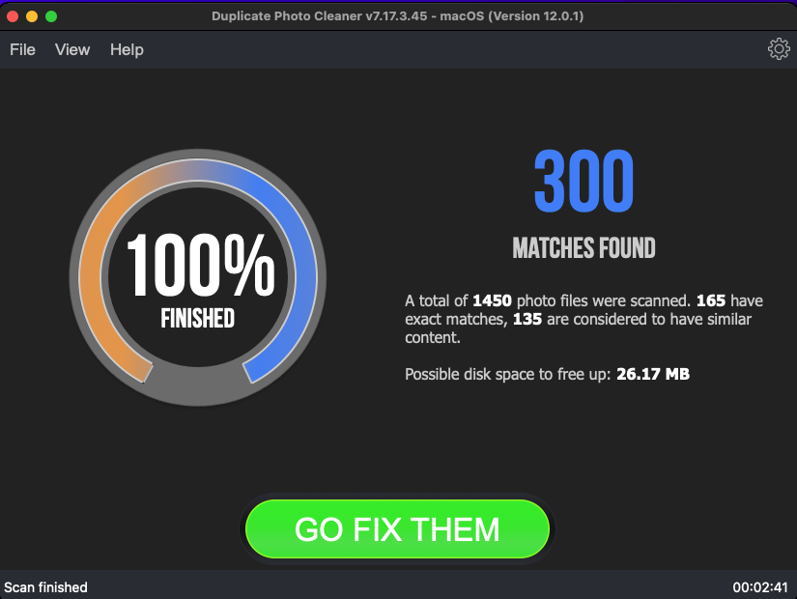

Figure 74 – Scan results summary page

1. Click **GO FIX THEM**. The scan results page is displayed as depicted in the figure below –

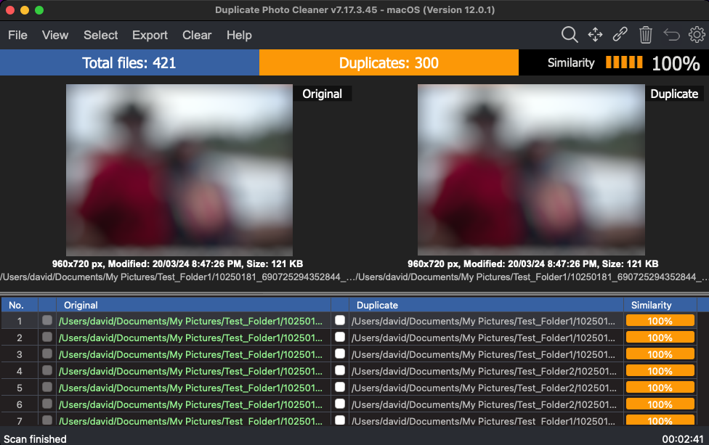

Figure 75 – Scan results details page

**Reference:** To save this scan, refer to Saving a Scan section. To import this scan later, refer to Importing a Scan section.

**Reference:** To perform multiple types of selections, refer to Viewing Modes Available for the Results on the Scan Details page section.

**Reference:** To export your scan results details as a file, refer to Exporting your Scan Result Details as a File section.

**Reference:** To clear the displayed scan results, refer to Clearing the Displayed Scan Results from Scan Results page section.

**Tip:** The source folders are treated as protected folders containing original photos. Therefore, these files listed in the original photo column are colored green and cannot be selected by you. This also indicates that these files are protected and that they cannot be deleted or moved by you.

1. After you have selected the duplicate files that you intend to delete or move, from the top right-hand corner on the scan results page, click Delete as depicted in the figure below –



Figure 76 – Scan Details Page Actions Menu

**Reference:** Refer to **Scan Detail Page Actions Menu Description** section for a detailed description of the buttons available on the Scan Details Page Actions Menu.

The next chapter describes steps that enable you to **Perform a Photo Scan**.

# Performing a Photo Scan

The Photo application enables you to manage, edit, and share your photos. The Photo library that you build automatically while using this application is prone to having multiple duplicate photos like any other photo library. The Duplicate Photo CleanerTM application enables you to directly load the Photo library and it enables you to identify duplicate photos.

The steps described below enable you to perform a Photo Scan –

1. After you launch the Duplicate Photo CleanerTM application, the default screen is displayed as depicted in the figure below –



Figure 77 – Performing a Photo Scan – DPC default screen

1. From the top right-hand corner click the Scan Mode drop-down and select the Photo Scan option. The Photo Scan page is displayed as depicted in the figure below –

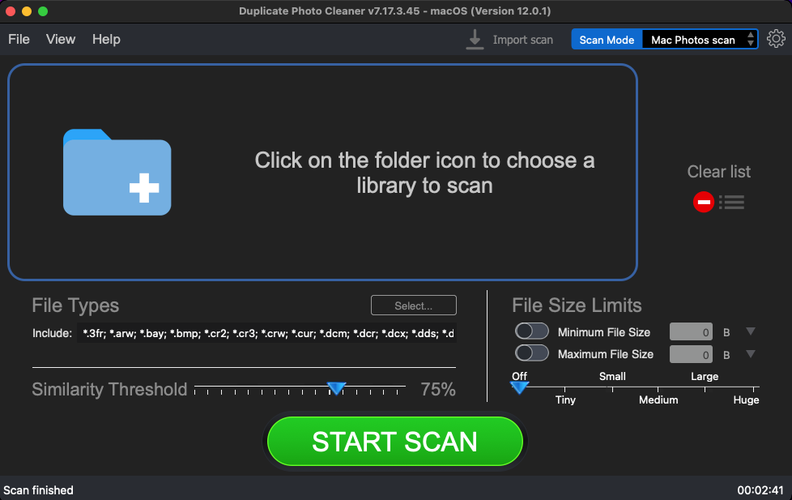

Figure 78 – Selecting the Photo Scan options

1. Select the Photo library by clicking the blue folder icon

Below are the functions along with a description of the parameters that you can tweak before you start a standard scan –

* + **Select library –** Clicking on the blue folder icon or by dragging the Photo library database file (.photolibrary file) and dropping it in the area as depicted in the figure above, enables you to select the target Photo library which is to be scanned
  + **Clear List –** Clicking this button clears the target library list
  + **File Types –** Clicking the Select button in this area as depicted in the figure above enables you to specify which file types are to be scanned for duplicates
  + **File Size Limits –** Specifying the maximum & minimum file sizes enables you to specify the size range of the files to be scanned. You can switch on the maximum & minimum limit applicability by swiping the slider button from left to right. Then you can specify the numerical values for both maximum & minimum limits and select the adjacent drop-downs to specify whether the limits must be considered in bytes (B), kilobytes (KB), megabytes (MB), or gigabytes (GB). After you specify the values in the fields described above, you will notice that the slider below changes to depict the whether the limits chosen signify Tiny, Small, Medium, Large, or Huge. Conversely, you can also use this slider instead of specifying the maximum & minimum limits
  + **Similarity Threshold –** You can utilize this slider to set the similarity threshold percentage which is to be set while searching for duplicate images

1. Click the blue folder icon or drag & drop a target library that you intend to scan. The specified library is selected & listed in target folder list as depicted in the figure below –

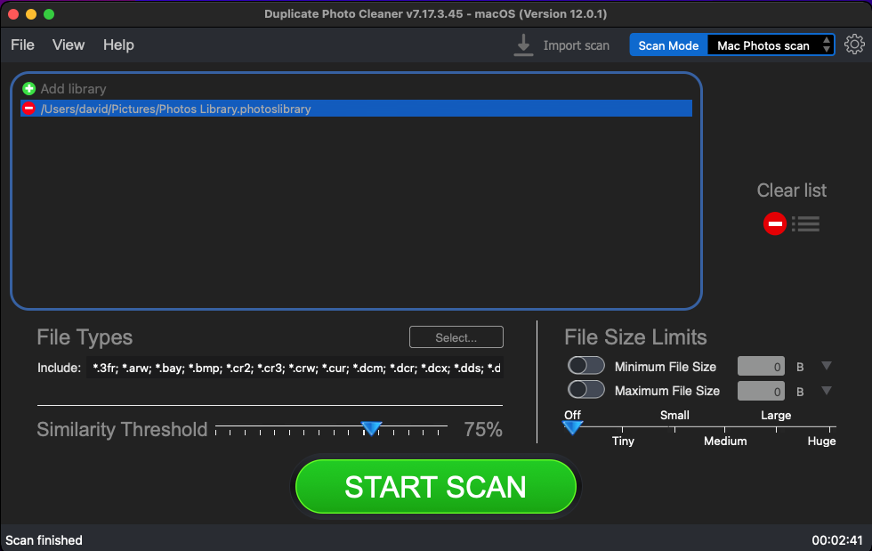

Figure 79 – Selecting the target Photo library

1. Specify the scan parameters as per your discretion and click Start Scan. Once the scan is finished, the scan results summary page is displayed as depicted in the figure below –

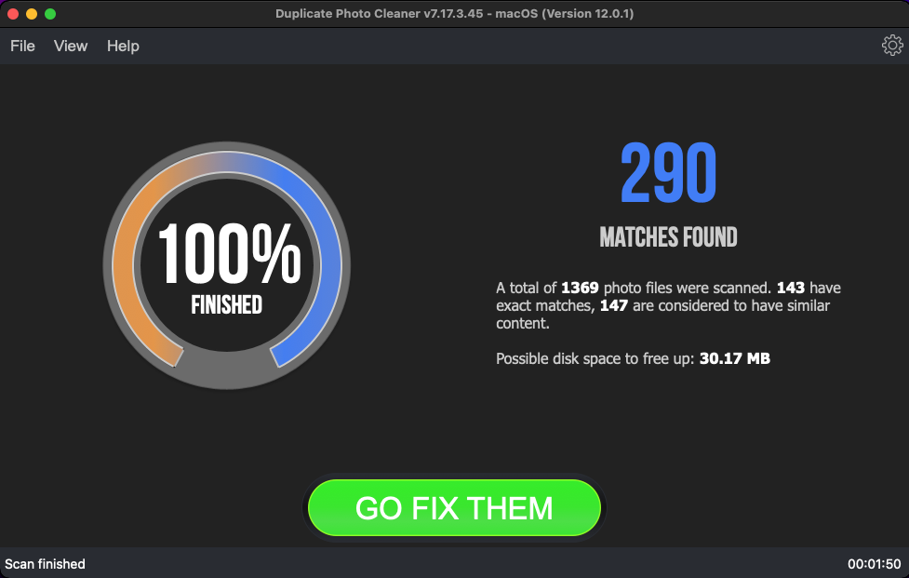

Figure 80 – Scan results summary page

1. Click **GO FIX THEM**. The scan results page is displayed as depicted in the figure below –

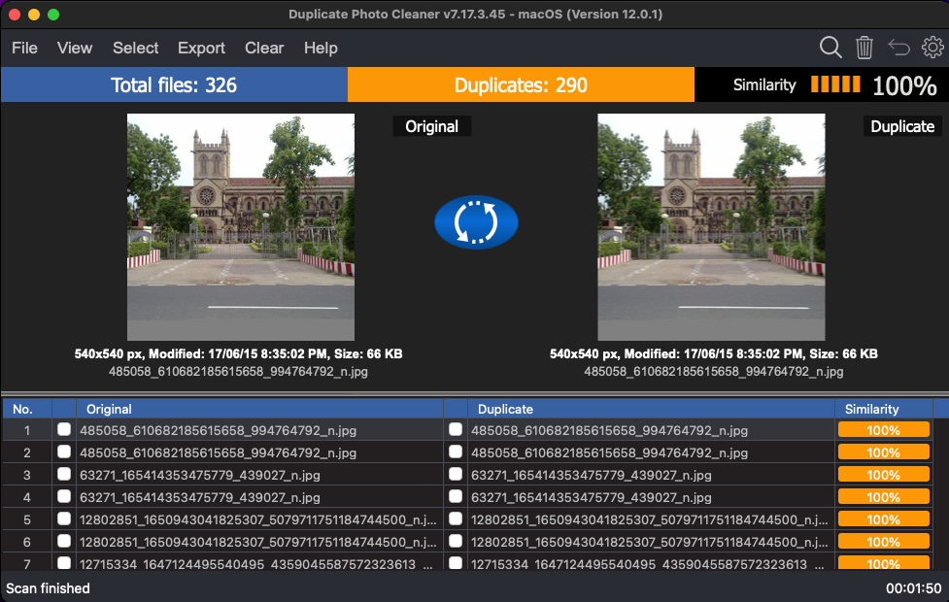

Figure 81 – Scan results details page

**Reference:** To save this scan, refer to Saving a Scan section. To import this scan later, refer to Importing a Scan section.

**Reference:** To perform multiple types of selections, refer to Viewing Modes Available for the Results on the Scan Details page section.

**Reference:** To export your scan results details as a file, refer to Exporting your Scan Result Details as a File section.

**Reference:** To clear the displayed scan results, refer to Clearing the Displayed Scan Results from Scan Results page section.

**Tip:** You can also click the Swap Images button available between the displayed original and duplicate image on screen in case you intend to keep the duplicate file while doing away with the original.

1. After you have selected the duplicate files that you intend to delete or move, from the top right-hand corner on the scan results page, click Delete as depicted in the figure below –



Figure 82 – Scan Details Page Actions Menu

**Tip:** Note that the move & links buttons are not available in the Photo scan details action menu. This is because Photo maintains its own library file with the filename Photos Library.photolibrary. DPC automatically navigates to the default folder location of this file when you choose to select the Photo library at step 3 in this process flow. DPC cannot make changes within this library as Photo handles its library in its own way.

**Reference:** Refer to **Scan Detail Page Actions Menu Description** section for a detailed description of the buttons available on the Scan Details Page Actions Menu.

The next chapter describes steps that enable you to **Perform a Lightroom Classic Scan**.

# Performing a Lightroom Classic Scan

Lightroom Classic enables you to edit your photos and organize your photo storage space. Moreover, this application enables you to catalog your photos & images as per your requirements. Again, like every other photo library, even a Lightroom Classic catalog is prone to having multiple duplicates files. This is where the Duplicate Photo CleanerTM application enables you to utilize your discretion identify duplicates and delete, move, or replace these duplicates with symbolic links.

The steps described below enable you to perform a Lightroom Classic Scan –

1. After you launch the Duplicate Photo CleanerTM application, the default screen is displayed as depicted in the figure below –



Figure 83 – Performing a Lightroom Classic Scan – DPC default screen

1. From the top right-hand corner click the Scan Mode drop-down and select the Lightroom Classic Scan option. The Lightroom Classic Scan page is displayed as depicted in the figure below –

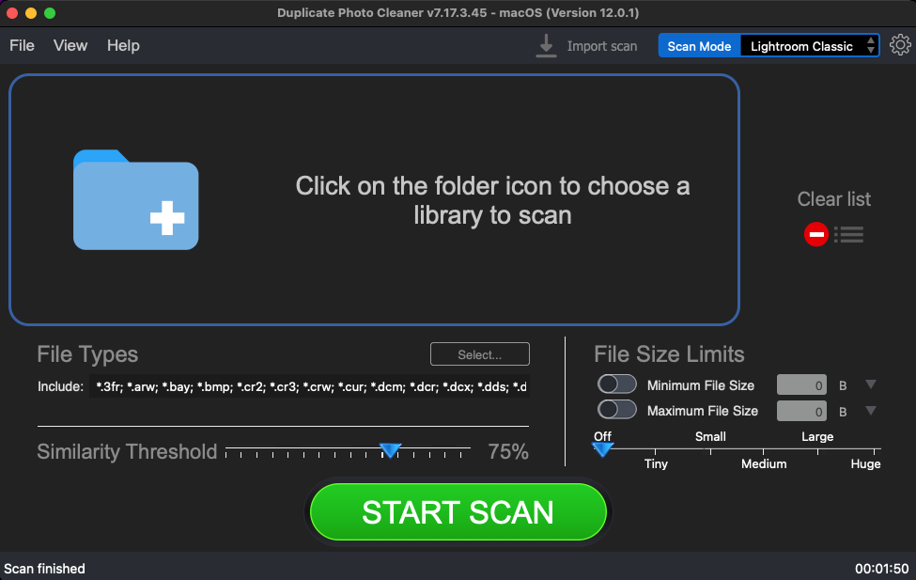

Figure 84 – Selecting the Light Room Classic scan options

1. Select the Lightroom Classic catalog by clicking the blue folder icon

Below are the functions along with a description of the parameters that you can tweak before you start a standard scan –

* + **Select catalog –** Clicking on the blue folder icon or by dragging the Lightroom Classic catalog file and dropping it in the area as depicted in the figure above, enables you to select the target Lightroom Classic catalog which is to be scanned
  + **Clear List –** Clicking this button clears the target catalog list
  + **File Types –** Clicking the Select button in this area as depicted in the figure above enables you to specify which file types are to be scanned for duplicates
  + **File Size Limits –** Specifying the maximum & minimum file sizes enables you to specify the size range of the files to be scanned. You can switch on the maximum & minimum limit applicability by swiping the slider button from left to right. Then you can specify the numerical values for both maximum & minimum limits and select the adjacent drop-downs to specify whether the limits must be considered in bytes (B), kilobytes (KB), megabytes (MB), or gigabytes (GB). After you specify the values in the fields described above, you will notice that the slider below changes to depict the whether the limits chosen signify Tiny, Small, Medium, Large, or Huge. Conversely, you can also use this slider instead of specifying the maximum & minimum limits
  + **Similarity Threshold –** You can utilize this slider to set the similarity threshold percentage which is to be set while searching for duplicate images

1. Click the blue folder icon or drag & drop a target library that you intend to scan. The specified library is selected & listed in target folder list as depicted in the figure below –

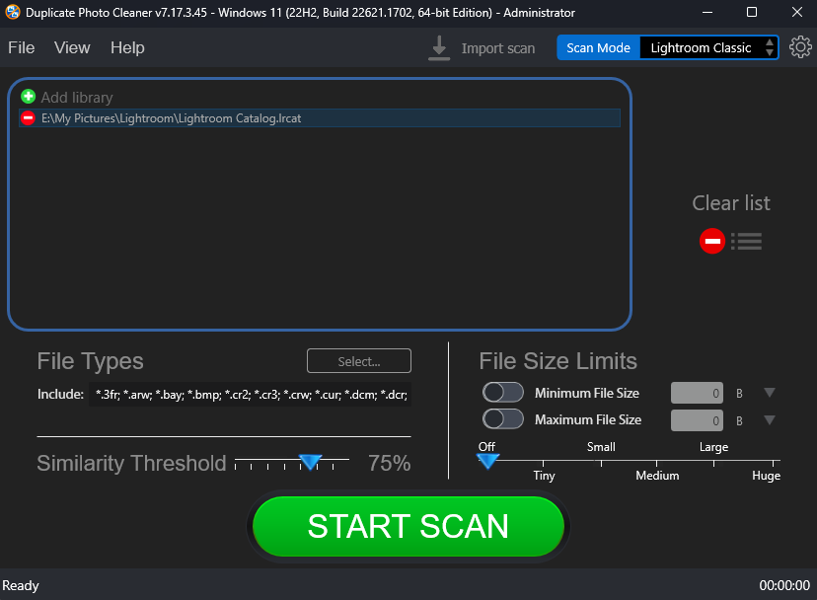

Figure 85 – Selecting the target catalog of Lightroom Classic

1. Specify the scan parameters as per your discretion and click Start Scan. Once the scan is finished, the scan results summary page is displayed as depicted in the figure below –

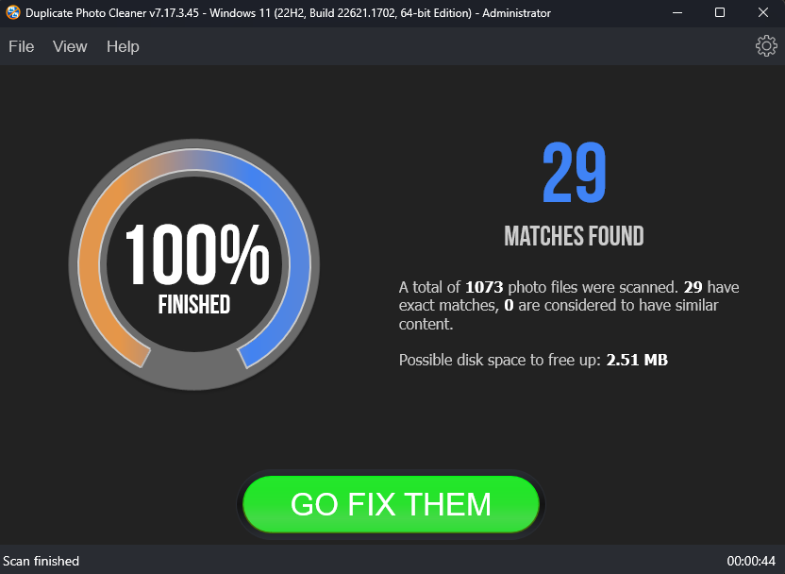

Figure 86 – Scan results summary page

1. Click **GO FIX THEM**. The scan results page is displayed as depicted in the figure below –

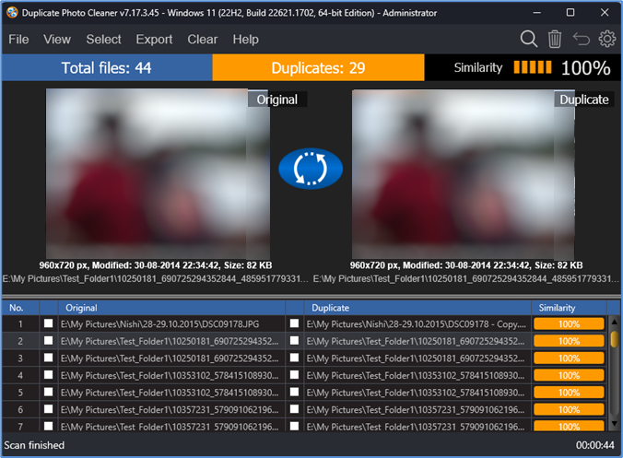

Figure 87 – Scan results summary page

**Reference:** To save this scan, refer to Saving a Scan section. To import this scan later, refer to Importing a Scan section.

**Reference:** To perform multiple types of selections, refer to Viewing Modes Available for the Results on the Scan Details page section.

**Reference:** To export your scan results details as a file, refer to Exporting your Scan Result Details as a File section.

**Reference:** To clear the displayed scan results, refer to Clearing the Displayed Scan Results from Scan Results page section.

**Tip:** You can also click the Swap Images button available between the displayed original and duplicate image on screen in case you intend to keep the duplicate file while doing away with the original.

1. After you have selected the duplicate files that you intend to delete or move, from the top right-hand corner on the scan results page, click Delete as depicted in the figure below –



Figure 88 – Scan Details Page Actions Menu

**Tip:** Note that the move & links buttons are not available in the Lightroom Classic scan details action menu. This is because Lightroom Classic maintains its own catalog file with the filename Lightroom Catalog.lrcat. DPC automatically navigates to the default folder location of this file when you choose to select the Lightroom Classic Catalog at step 3 in this process flow. DPC cannot make changes within this catalog as Lightroom Classic handles its library in its own way.

**Reference:** Refer to **Scan Detail Page Actions Menu Description** section for a detailed description of the buttons available on the Scan Details Page Actions Menu.

The next chapter describes steps that enable you to **Perform a Fragment Search**.

# Performing a Fragment Search

The Fragment scan mode is very similar to Folder Comparison scan, but this scan mode uses a single file as a source. You can use this scan mode to search a whole image or just a selected part of it.

**Tip:** For the whole image you can use Similarity threshold as usual, but when searching for a selected fragment you should set the similarity threshold to 100%.

The steps described below enable you to perform a Fragment Search –

1. After you launch the Duplicate Photo CleanerTM application, the default screen is displayed as depicted in the figure below –



Figure 89 – Performing a Fragment Search – DPC default screen

1. From the top right-hand corner click the Scan Mode drop-down and select the Fragment Search option. The Fragment Search page is displayed as depicted in the figure below –

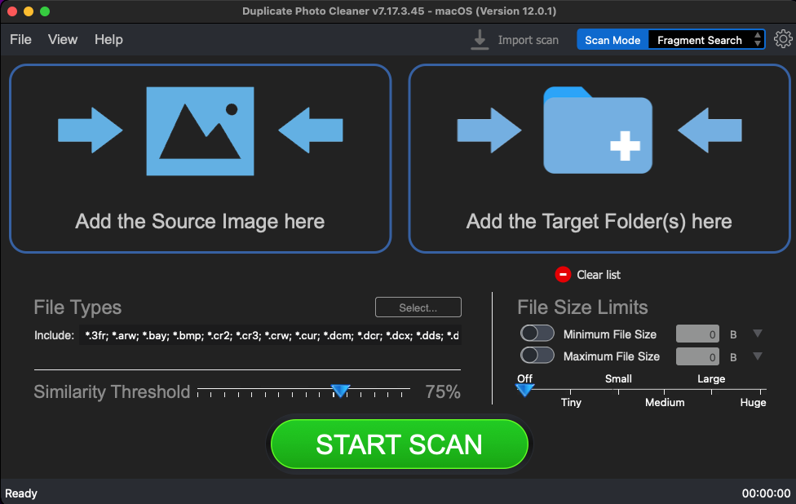

Figure 90 – Selecting the source image and target folder(s)

1. Select the Source image and the Target Folders by clicking the corresponding blue folder icons

Below are the functions along with a description of the parameters that you can tweak before you start a standard scan –

* + **Select Source Image –** Clicking on the blue corresponding folder icon or by dragging a folder and dropping it in the corresponding area as depicted in the figure above, enables you to select a source image, a selected fragment of which is to be scanned against the target folder being specified in the next point.
  + **Select folder –** Clicking on the blue corresponding folder icon or by dragging a folder and dropping it in the corresponding area as depicted in the figure above, enables you to select a target folder which is to be scanned with reference to the selected source area which you can specify using your mouse as indicated in the figure in step 4 in this process flow.
  + **Clear List –** Clicking the corresponding button clears the source and target folder lists
  + **File Types –** Clicking the Select button in this area as depicted in the figure above enables you to specify which file types are to be scanned for duplicates
  + **File Size Limits –** Specifying the maximum & minimum file sizes enables you to specify the size range of the files to be scanned. You can switch on the maximum & minimum limit applicability by swiping the slider button from left to right. Then you can specify the numerical values for both maximum & minimum limits and select the adjacent drop-downs to specify whether the limits must be considered in bytes (B), kilobytes (KB), megabytes (MB), or gigabytes (GB). After you specify the values in the fields described above, you will notice that the slider below changes to depict the whether the limits chosen signify Tiny, Small, Medium, Large, or Huge. Conversely, you can also use this slider instead of specifying the maximum & minimum limits
  + **Similarity Threshold –** You can utilize this slider to set the similarity threshold percentage which is to be set while searching for duplicate images

1. Click the blue folder icon or drag & drop a target folder that you intend to scan. The specified folder is selected & listed in target folder list as depicted in the figure below –

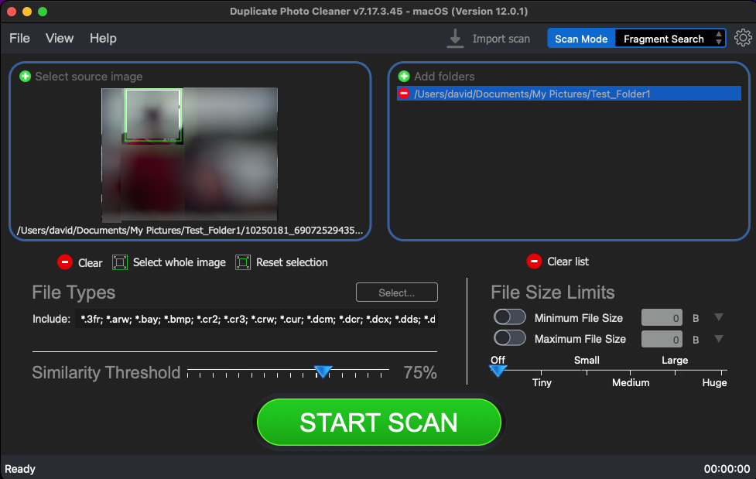

Figure 91 – Selecting one or more source & target folders

Below is a description of the additional functions which you can perform –

* + **Select fragment –** Using your mouse you can specify the fragment of the source image that is to be scanned against the photos in the target folder as green square.
  + **Clear –** Clicking this button clears the source image
  + **Select whole image –** Clicking this button selects the whole source image
  + **Reset selection –** Clicking this button resets the currently specified fragment

**Tip:** You can add more folders in the source and target folder list by clicking the corresponding green Add folders button as depicted in the figure above.

1. Specify the scan parameters as per your discretion and click Start Scan. Once the scan is finished, the scan results summary page is displayed as depicted in the figure below –

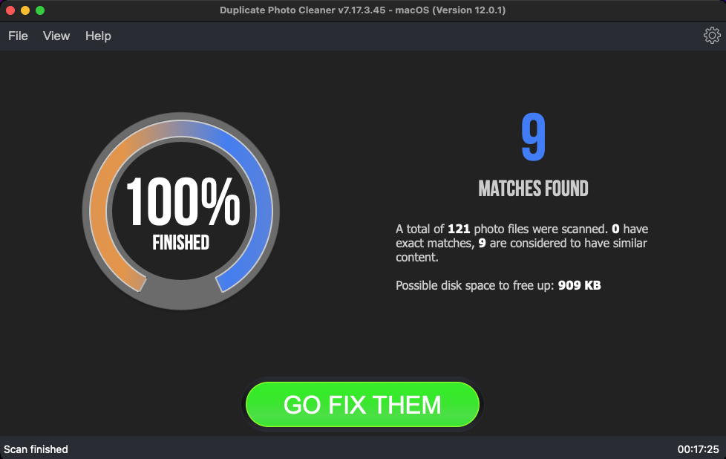

Figure 92 – Scan results summary page

1. Click **GO FIX THEM**. The scan results page is displayed as depicted in the figure below –

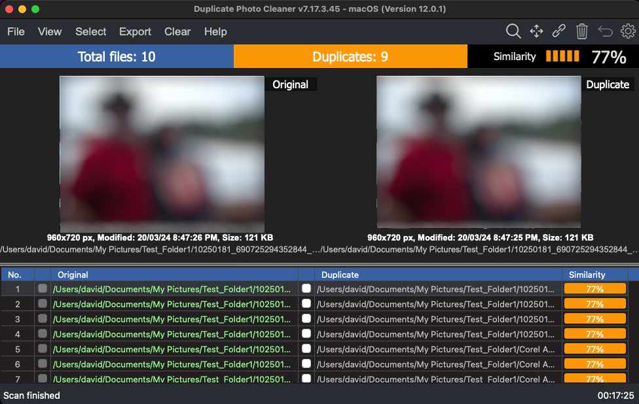

Figure 93 – Scan results details page

**Tip:** The source photo files are treated as protected files as they are considered as original photos. Therefore, these files listed in the original photo column are colored green and cannot be selected by you. This also indicates that these files are protected and that they cannot be deleted or moved by you.

**Reference:** To save this scan, refer to Saving a Scan section. To import this scan later, refer to Importing a Scan section.

**Reference:** To perform multiple types of selections, refer to Viewing Modes Available for the Results on the Scan Details page section.

**Reference:** To export your scan results details as a file, refer to Exporting your Scan Result Details as a File section.

**Reference:** To clear the displayed scan results, refer to Clearing the Displayed Scan Results from Scan Results page section.

1. After you have selected the duplicate files that you intend to delete or move, from the top right-hand corner on the scan results page, click Delete as depicted in the figure below –



Figure 94 – Scan Details Page Actions Menu

**Reference:** Refer to **Scan Detail Page Actions Menu Description** section for a detailed description of the buttons available on the Scan Details Page Actions Menu.

The next section of this user manual **Frequently Asked Questions (FAQs)** as an appendix.

1. Frequently Asked Questions (FAQs)

Here is a list of frequently asked questions with reference to the Duplicate Photo CleanerTM application and its usage –

Why do I need Duplicate Photo Cleaner™?

Duplicate Photo CleanerTM is the app that makes it easy to move all your files, user profiles, settings, software and even drivers from one computer to another. It's perfect for configuring a new computer with all your stuff, syncing folders, and keeping data and settings the same on two or more computers.

How do I install Duplicate Photo CleanerTM on a macOS PC?

**Tip:** Refer to Downloading the DPC Application Installer section

After you have downloaded the .dmg installer follow the steps provided below –

1. Double-click on the file you've just downloaded. A small window will appear as depicted in the figure below –

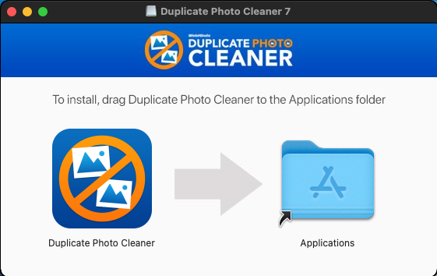

Figure 95 – Installing DPC in macOS

1. Drag and Drop the Duplicate Photo CleanerTM icon in the Applications folder
2. Close the window
3. Go to the Applications folder or to the Launchpad and launch Duplicate Photo CleanerTM from there
4. When you open Duplicate Photo Cleaner for the first time, your Mac may ask you if you are sure you want to open Duplicate Photo Cleaner. Click Open to launch the app.

I have folders with intentional copies of my photos that I use as backups. How can I exclude them from DPC's scans?

You'll need to add these folders to the Ignore List. To do that, go to Settings, click on the Ignore List tab, and add the folders you want to exclude from scans.

What are the trial version limitations?

The trial version of Duplicate Photo CleanerTM offers unlimited scanning for duplicates and similar images. You can then delete up to 10 duplicate groups with the trial version.

I thought I had purchased a license for 3 computers, but it looks like I've purchased a single-PC license. Is there any way to upgrade my license for the price difference between the two?

Please log into your account from [this](https://www.duplicatephotocleaner.com/login) page. To the right of your license key, you'll see two links – to renew and to upgrade. Click on the Upgrade button and follow the prompts.

I want to install Duplicate Photo CleanerTM on another computer using my current license key. Is that possible?

If you ever need to reinstall Duplicate Photo CleanerTM or move it to a different computer, you should copy your license key and unregister the program before you do anything else. To do that click on "Help" and go to the "About" screen inside the program. Then make a note of your license key and remove the key. This will reset the license so that you can reactivate it on a new installation (this feature is limited to 3 times).

**Note:** if your license key has expired, please visit the Version History page on the site and download the version that was released before your key expired. An expired key will not activate any version released after the key's expiration.

**Tip:** For more information, refer to Activating your DPC Installation and Removing your DPC License Details chapters.

My computer is not connected to the Internet. Is there a way to activate Duplicate Photo CleanerTM offline?

Follow these steps to activate Duplicate Photo CleanerTM on a computer that's not connected to the Internet:

1. Purchase a license key and install Duplicate Photo CleanerTM on your computer.
2. Open Duplicate Photo CleanerTM, click on Help in the menu and go to "About".
3. Copy the product key from the popup that appears.
4. Go to [**this**](https://www.duplicatephotocleaner.com/support) page and open a support ticket. Make sure you send both your product key and your license key to the Support Team.
5. Our Support Team will generate activation data for your copy of Duplicate Photo CleanerTM and email it to you.
6. Copy the activation data from the email, save it as a text file and put the file on a flash drive.
7. Connect the flash drive to your offline computer, open the text file with the activation data, select all of it and copy it. Important: don't paste it anywhere at this point!
8. Open Duplicate Photo CleanerTM. If you have valid activation data and if you've followed these steps correctly, your copy of Duplicate Photo CleanerTM will become activated.

If you're on Windows, you can ask the Support Team to email you a Master File that you can save to the folder where Duplicate Photo CleanerTM is installed. Then simply open Duplicate Photo CleanerTM and it will get activated.

I'm updating my macOS to a higher version. Will your software continue to work?

We've become aware of a Duplicate Photo CleanerTM registration glitch that some people experience when they update to Windows 10. We've investigated the problem and found a solution. So, if you are planning to update to Windows 10, please follow these steps before you run the update:

1. Open Duplicate Photo CleanerTM and click on "About" in the top right corner
2. Make a note of your registration code, then select "Remove key" and close the program
3. Update your operating system to Windows 10
4. Open Duplicate Photo CleanerTM again and click on the "Register Now" button
5. Close the Web page that opens (you don't need that page because you already have your license code)
6. Enter your license code and the e-mail address you used to register in a pop-up window that appears
7. Click "Activate" and continue to enjoy Duplicate Photo CleanerTM

What formats does Duplicate Photo CleanerTM support?

Duplicate Photo Cleaner supports BMP, JPG, JPEG, JFIF, PNG, TIF, TIFF, GIF, ICO, WMP, ICNS, PSD, TGA, RAW, CRW, CR2, CR3, NEF, PEF, RAF, X3F, BAY, ORF, SRF, MRW, DCR, SR2, DNG, RW2, ARW, HEIC, HEIF, 3FR, DCX, DIB, EMF, JPS, HDP, PBM, PGM, PNS, PPM, PCT, CUR, WEBP, BAY, ERF, KDC, RWL, MEF, NRW, PTX, SRW, RLE, DDS, WDP, JXR, HDP, JPE, JIF, J2K, JPC, J2C, JP2, PCX, SVG, DCM, DIC, DICOM and V2.

How do I configure Duplicate Photo CleanerTM to detect only exact duplicates?

All you need to do is set the image similarity threshold to 100%. To do that, open the program and click on Settings. In the new window go to the File Search tab and move the image similarity threshold slider to 100%. Click OK to save your settings.

How can I get more information about the images?

Setting the scan results view to tree view will make the program display information like image width and height, size, and modification date in addition to image location. To change your view settings to tree view, click on the View result menu item and select as Tree.

I want to scan for duplicate JPG images only. How can I prevent the program from detecting GIF, BMP and PNG files?

Simply go to program settings, navigate to the File Search tab, and uncheck BMP, GIF and PNG. Click OK to save your settings.

What is the benefit of comparing photos in grayscale?

Comparing photos in grayscale will help you get more matches without lowering the image similarity threshold. When you search for duplicate and similar photos in grayscale as opposed to in full color, Duplicate Photo CleanerTM disregards color changes. This method allows you to find more duplicate photos and more similar images you may want to move or delete.

To compare photos in grayscale, go to Duplicate Photo CleanerTM settings and check "Use grayscale comparison" on the File Search tab.

What is Sector Detail Scan and how does it work?

Sector Detail Scan is a scan mode introduced in Duplicate Photo CleanerTM 2.8. This mode lets you select a sector on an image and search other images for that specific sector. Here is how to use it:

1. Select "Sector Detail Scan" as your scan mode
2. Select the folders you want to scan for similar images
3. Add a photo and select a sector on it that you want to find in other images
4. Start the scan

Because Sector Detail Scan is very precise, it can take several hours to complete the scan. To make your scans faster, we suggest that you set the similarity threshold to 50% and scan smaller folders.

What is the difference between Easy Duplicate Finder™ and Duplicate Photo CleanerTM?

Both [**Easy Duplicate Finder**](https://www.easyduplicatefinder.com/)™ and Duplicate Photo CleanerTM are designed to find and delete duplicate files. The main difference between these two apps is that Easy Duplicate Finder™ works with duplicates of all file types, whereas Duplicate Photo CleanerTM works with images only. In addition to that, Easy Duplicate Finder™ can only find exact duplicates. Duplicate Photo Cleaner is different because it can detect both identical and similar images, such as resized and edited photos. It can also find photos in different formats (a .JPG file vs. a .PNG file, for example).

If you are having trouble choosing between Easy Duplicate Finder™ and Duplicate Photo CleanerTM, ask yourself what types of duplicates you want to find. Easy Duplicate Finder™ is ideal if you want to delete duplicate documents, songs, photos, emails, and videos from your computer. But if all you want to do is organize your extensive image library, consider getting Duplicate Photo CleanerTM. It will not only help you find and delete duplicate photos, but also let you easily sort through similar shots and decide which ones to keep and which to delete or move.

How can I select multiple images when the scan is complete?

You can select images you want to delete in bulk on the Scan Results screen. Use the "Select Photos" drop-down menu to select all duplicates, select all originals, or select only high or low-resolution images.

How can I delete multiple files in Duplicate Photo CleanerTM?

To delete several files in one go, select the files you want to delete and then click on the trash can icon in the top right corner of the app screen.

I have a really large photo library. What's the best way to manage it with Duplicate Photo CleanerTM?

If you have a very large photo library, follow these steps to make deleting duplicate and similar photos as efficient as possible:

1. Go to Duplicate Photo CleanerTM settings and set the similarity threshold to 100%, then scan your whole photo library. This will allow you to find exact duplicates and delete them in a single click.
2. When your photo collection is free from exact duplicates, go back to the Settings panel and set the similarity threshold to 85%.
3. Break up your photo library into several manageable parts, scan it part by part, and resolve similar images in each part.
4. When done, scan your whole photo library once again to find any duplicates and similar photos you might have missed.

Is there a way to compare images in folder A against images in folder B with Duplicate Photo CleanerTM?

Simply go to the Scan Mode drop-down menu and choose Folder Comparison. Then add a source folder to the left drag & drop area and Duplicate Photo CleanerTM will treat files in this folder as the originals. Then add the folders you want to compare against the source folder to the target scan area to the right and run a scan. When done, use Duplicate Photo CleanerTM to delete the duplicates as you normally would.

What exactly does the Folder Comparison scan mode do?

The Folder Comparison mode is a special scan mode that makes it easy to compare images in two or more folders. It treats files in Source Folders as originals (master files), thus helping you to avoid any confusion when you're choosing which photos to delete and which to keep. This mode is great for comparing files on external drives with images on your computer and merging folders.

How does Duplicate Photo CleanerTM decide which photos are the originals and which are the duplicates?

When you are using most scan modes, Duplicate Photo CleanerTM considers the first image in a group of duplicates the original file.

When you switch to the Folder Comparison mode, all the files in the Source Folder(s) are treated as the originals, while the photos in target folders are marked as the duplicates.

In Sector Detail Scan mode, the source image file is the original.

What is multi-threaded image processing?

This feature makes Duplicate Photo CleanerTM use all available CPU cores for image processing. Enabling this feature makes the scan up to 50% faster.

How does Duplicate Photo CleanerTM? Does it simply compare Meta (EXIF) data or does it compare the actual images?

Duplicate Photo CleanerTM uses an advanced algorithm to compare the actual images, just like a human would. Depending on the program settings, it may take EXIF data into account when determining image similarity level.

Which versions of Adobe Lightroom are supported?

Duplicate Photo CleanerTM supports Adobe Lightroom 6 and newer. If you have an older version on your computer, the Lightroom Scan mode will not appear in the Scan Modes menu.

How to use the Search / Filter results feature in DPC?

The Search / Filter results feature offers you a handy way to go through the scan results and manage your photos more effectively. You can open the Search / Filter window by clicking on the "Search" icon in the top right corner of the results window.



Figure 96: Opening the Search / Filter window

The search tool lets you search / filter files by name, by date, by size, and by duplicate group.

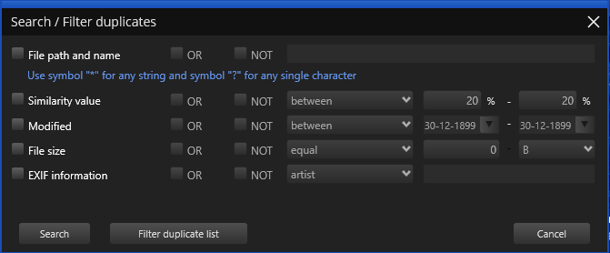

Figure 97: Search / Filter window

The file name field allows you to use wildcard characters where an asterisk (*) represents one or more characters and the question mark (?) represents a single character.

The asterisk in a wildcard matches any character that appears zero or more times. For example, "comp*" matches anything beginning with "comp" which means "comp," "complete," and "computer" are all matched.

The question mark stands for a single character mentioned only once. For example, "c?mp" could be either "camp" or "comp".

You can use this feature and wildcard characters to search DPC scan results quickly and effectively to find the images you need.

How do I save a scan and import it later?

**Reference:** To Save a scan, refer to **Saving a Scan** section.

**Reference:** To Import a saved scan, refer to **Importing a Scan** section.

Can I use Duplicate Photo CleanerTM to delete duplicate photos from my smartphone?

Yes, you can! Simply connect your phone to your Windows PC and open Duplicate Photo CleanerTM. It will automatically detect a connected phone and offer to scan it for duplicate and similar photos. Alternatively, open DPC, select Media Device Scan from the scan modes drop-down menu and connect your phone. Your phone may ask you to give Duplicate Photo CleanerTM the necessary permissions (check your phone for notifications). When done, follow DPC's prompts to scan your phone.

Does Duplicate Photo CleanerTM support Android and iOS devices?

You can use DPC to scan your iOS and Android devices for duplicate and similar photos by connecting your phone to your Windows PC and using DPC's Media Device Scan mode.

Do I have to add all the folders with photos when using the Media Device Scan mode?

No, you don't need to add folders one by one. Duplicate Photo CleanerTM uses the Media Transfer Protocol to scan photos on your smartphone, which means that all you need to do is connect your phone and DPC will detect and scan all the photos on the device.

How does Duplicate Photo CleanerTM determine which image is the original and which is the duplicate?

DPC sees an image as the original based on a set of conditions. Here they are in order of priority:

* the file has the largest resolution in the group
* the file has the largest size in the group
* the file is the "newest" in the group (determined by modification date)

My scan got stuck! What to do?

If your scan with Duplicate Photo CleanerTM got stuck or is very slow, don't panic because most likely it's not a bug. This could be happening because you've chosen a very accurate scan mode and added too many images for Duplicate Photo CleanerTM to compare. Just stop your current scan and try the following:

* Add smaller folders - don't scan your entire image library in one go
* If you are using Sector Detail Scan, lower the similarity threshold to 50% and never add large folders
* Eliminate true duplicates first - select Standard Scan and set the similarity threshold to 100%, delete the duplicates and then start looking for similar images in smaller chunks

This will help you speed up Duplicate Photo CleanerTM scans and manage your photos more effectively.

I accidentally closed Duplicate Photo CleanerTM. Is there a way for me to load previous scan results?

Duplicate Photo CleanerTM doesn't save your scan progress automatically but it offers you an option to pause and resume scans. If you've paused a scan, DPC will resume it right where it left off even if you've closed the application.

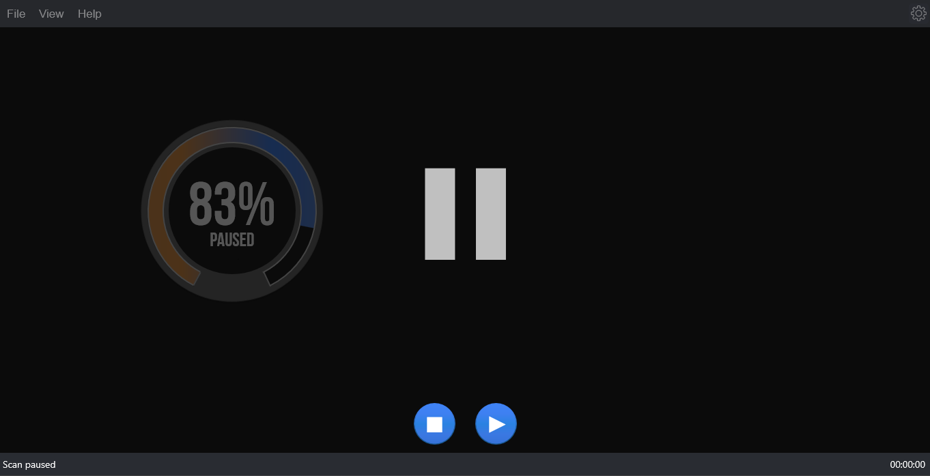

Figure 98: Pausing a scan

We recommend that you use the Pause feature if you decide to abort a scan because you don't have the time to sort through the results. This will speed things up a great deal.

My system crashed and Duplicate Photo CleanerTM got unregistered. How do I get my software up and running again?

First, go to [**www.duplicatephotocleaner.com**](http://www.duplicatephotocleaner.com), download the .dmg (MacOS) installation file depending upon your operating system and install Duplicate Photo CleanerTM. If you have a license key, you can log into your account with the email address used when you purchased your license key from [**this**](https://www.duplicatephotocleaner.com/login) page. There you will see your current license key. You can also find your license key in the email we sent you when you purchased Duplicate Photo CleanerTM. Use the key to activate Duplicate Photo CleanerTM by running the program and entering the license key in the activation box.

If you discover that your license key has expired, make sure you go to the "[**Version History**](https://www.duplicatephotocleaner.com/history)" page and install an older version, the one for which you bought the key. Duplicate Photo CleanerTM will work as it should, although you won't be able to download updates. Your key should activate any version released prior to your software expiring.

If you lost your license key, please submit a [**support ticket**](https://www.duplicatephotocleaner.com/ticket) and send us all the relevant information about your purchase.

I have a drive that has only photos on it. After about 15 minutes of scanning, the program hangs.

Duplicate Photo CleanerTM supports large amounts of files and works on large drives. Please make sure your drive is not damaged and doesn't have bad sectors. Also please make sure you have the latest version of Duplicate Photo CleanerTM installed. You can check for new versions by opening the program, clicking on Help in the menu and clicking on Update.

Duplicate Photo CleanerTM reported that some duplicate files could not be deleted. Why is that and how can I fix this?

There could be several reasons why Duplicate Photo CleanerTM is not deleting these files. Here are the most common fixes for this problem:

1. The files you are trying to delete are being used by another application. Close all programs except Duplicate Photo CleanerTM and try deleting the duplicates again.
2. Make sure the files you're trying to delete aren't located on a read-only drive, like a CD or a DVD.

I use Windows tags to organize my photos and I want to delete images that don't have them. Can DPC help?

Absolutely! Duplicate Photo CleanerTM supports Windows tags. Simply scan your image library and wait for the results to be displayed. You can hover over image thumbnails in Multiviewer to view EXIF data and Windows tags. When you are ready to select the images based on Windows tags, use the "Select files with tags" and "Select files without tags" bulk selection options.

Can I launch Duplicate Photo CleanerTM to scan a specific folder when I'm browsing my computer?

Yes. Duplicate Photo CleanerTM supports Windows context menu, so all you need to do is right-click on a folder you want to scan and select Duplicate Photo CleanerTM.

After the search is complete, I click "Select files with the original names" and no files are selected in some duplicate groups. Why is that?

This means that DPC couldn't identify the original for these groups. When DPC cannot determine the original file in the group because all files match the same criteria (i.e., have the same file name), it will not select any files in the group. You can still use bulk selection options that use different criteria.

When I click "Reverse selection", both files in groups where the bulk selections didn't work become selected.

That's because the "Reverse selection" option changes the selection to the opposite state (selected -> non-selected, non-selected -> selected)

The next section of this user manual includes an **Index** of frequently referred terms or phrases with reference to the Duplicate Photo CleanerTM application and its usage.

Index

A

Abbreviations / Acronyms used in this User Manual v

About this User Manual iii

Activating your DPC Installation 61

C

Clearing the Displayed Scan Results from Scan Results page 36

D

Downloading the DPC Application Installer 11

E

Entering a New Key 64

Exporting your Scan Result Details as a File 33

F

Frequently Asked Questions (FAQs) 95

G

Getting Started 12

I

Importing a Scan 25

In Scope of this User Manual iii

Intended Audience of this User Manual iii

Introduction 11

L

Limitations of Utilizing an Unregistered DPC Application in Trial Mode 23

O

Opening the Settings Panel 54

Organization of this User Manual iii

Out of Scope of this User Manual iii

P

Performing a Delete Duplicate Photos Action 50

Performing a Folder Comparison 74

Performing a Fragment Search 89

Performing a Lightroom Classic Scan 84

Performing a Link Duplicate Photos to Original Photos Action 47

Performing a Move Duplicates Action 44

Performing a Photo Scan 79

Performing a Search / Filter Duplicates Action 39

Performing a Standard Scan 70

Performing an Undo Action 53

Performing General Functions during all Scan Types 23

Performing Multiple Types of Selections on the Scan Results page 31

Purpose of this User Manual iii

R

Registering your DPC Application Installation 55

Removing your DPC License Details 67

S

Saving a Scan 23

Scan Detail Page Actions Menu Descriptions 38

T

Terms Used in this User Manual v

The General tab 14

The Ignore List tab 20

The Logging tab 19

The Scan Settings tab 17

The Settings Panel Detailed Description 14

The Sounds tab 21

The Support tab 22

Typographical Conventions / Customaries used in this User Manual iv

U

Using the Mouseover Menu on the Image Preview 37

V

Via the DPC Homepage 55

Via the Register Button of DPC Application 58

Viewing Modes Available for the Results on the Scan Details page 27

W

Why do I need Duplicate Photo Cleaner™? 95